|  |
| --- |
| Name: J A Mujeeb |
| Student Reference Number: 10707284 |



|  |  |  |
| --- | --- | --- |
| Module Code: ISAD253SL | Module Name: ISAD253SL Databases (20/AU/M) | |
| Coursework Title:  ISAD253SL C1 P1 | | |
| Deadline Date:  04/01/2021 | | Member of staff responsible for coursework:  Naji Saravanabavan |
| Programme:  BSc (Hons) Software Engineering (4872) | | |
| Please note that University Academic Regulations are available under Rules and Regulations on the University website [www.plymouth.ac.uk/studenthandbook](http://www.plymouth.ac.uk/studenthandbook). | | |
| Group work: please list all names of all participants formally associated with this work and state whether the work was undertaken alone or as part of a team. Please note you may be required to identify individual responsibility for component parts.  S O Perera – 10707315  G M D D Rathnayake – 10707351  S S N S Nevins – 10707291  W N D Perera - 10707045  S P Ratnayake – 10707051  We confirm that we have read and understood the Plymouth University regulations relating to Assessment Offences and that we are aware of the possible penalties for any breach of these regulations. We confirm that this is the independent work of the group.  Signed on behalf of the group: Shape  Description automatically generated with medium confidence | | |
| Individual assignment: I confirm that I have read and understood the Plymouth University regulations relating to Assessment Offences and that I am aware of the possible penalties for any breach of these regulations. I confirm that this is my own independent work.  Signed : | | |
| Use of translation software: failure to declare that translation software or a similar writing aid has been used will be treated as an assessment offence.  I *have used/not used translation software.  If used, please state name of software – SQL Server Management Studio | | |
| Overall mark _____% Assessors Initials ______ Date: 04/01/2021______ | | |

*Please delete as appropriateSci/ps/d:/students/cwkfrontcover/2013/14

Contents

List of Figures 4

Section 01 6

Basic Introduction 6

Enhanced entity-relationship (EER) Diagram 6

Assumption 6

Relational Mapping Diagram 7

Normalization 8

Data Dictionary 8

Section 02 9

Creating Table 9

Database Diagram 18

Section 03 18

View 18

Trigger 19

Function 20

Procedure 23

Section 04 24

Worthy features 24

Together with any shortcomings 25

How they might be resolved 25

Future Implementation 25

Screenshots of everything remaining 25

Workload Matrix 35

# List of Figures

Figure 1: Enhanced Entity-Relationship Diagram 6

Figure 2: Relational Mapping Diagram 7

Figure 3: Normalization Diagram 8

Figure 4: Library (Create Code) 9

Figure 5: Library Location (Create Code) 10

Figure 6: Library Academic (Create Code) 10

Figure 7: Library Special (Create Code) 10

Figure 8: Library Special (Create Code) 11

Figure 9: Employee (Create Code) 11

Figure 10: Employee Qualification (Create Code) 11

Figure 11: Employee Librarian (Create Code) 12

Figure 12: Employee Director (Create Code) 12

Figure 13: Employee Medical Librarian (Create Code) 12

Figure 14: Employee Medical Specialist (Create Code) 13

Figure 15: Employee Assistant (Create Code) 13

Figure 16: Employee Library Aid (Create Code) 13

Figure 17: Employee Archivists (Create Code) 14

Figure 18: Employee Technician (Create Code) 14

Figure 19: Employee Clerk (Create Code) 14

Figure 20: Employee Publisher (Create Code) 15

Figure 21:Book (Create Code) 15

Figure 22: Member (Create Code) 15

Figure 23: Member Kindergarten (Create Code) 15

Figure 24: Member Student (Create Code) 16

Figure 25: Member Undergraduate (Create Code) 16

Figure 26: Member Postgraduate (Create Code) 16

Figure 27: Member Other (Create Code) 17

Figure 28: Copy (Create Code) 17

Figure 29: Copy Location (Create Code) 17

Figure 30: Has Relationship (Create Code) 17

Figure 31: Borrow Relationship (Create Code) 18

Figure 32: Database Diagram 18

Figure 33: View 18

Figure 34: 2nd View 19

Figure 35: 1st Trigger 19

Figure 36: 2nd Trigger Create Code 20

Figure 37: 2nd Trigger insertion 20

Figure 38: 2nd Trigger Execution 20

Figure 39: 1st Function Creation 21

Figure 40: 1st Function Execution 21

Figure 41: 2nd Function (Create Code) 22

Figure 42: 2nd Function (Execution) 22

Figure 43: 2nd Function (selection code) 23

Figure 44: 1st Procedure (create) 23

Figure 45: 1st Procedure (Execution) 24

Figure 46: 1st Procedure (create) 24

Figure 47: 2nd Procedure 24

Figure 48: Library (Value Insertion) 25

Figure 49: Library Location (Value Insertion) 25

Figure 50: Library Academic (Value Insertion) 26

Figure 51: Library Public (Value Insertion) 26

Figure 52: Library Special (Value Insertion) 26

Figure 53: Employee (Value Insertion) 27

Figure 54: Employee Qualification (Value Insertion) 27

Figure 55: Employee Librarian (Value Insertion) 28

Figure 56: Employee Director (Value Insertion) 28

Figure 57: Employee Medical Librarian (Value Insertion) 28

Figure 58: Employee Media Specialist (Value Insertion) 29

Figure 59: Employee Assistant (Value Insertion) 29

Figure 60: Employee Library Aid (Value Insertion) 29

Figure 61: Employee Archivists (Value Insertion) 30

Figure 62: Publisher (Value Insertion) 30

Figure 63: Book (Value Insertion) 31

Figure 64: Member (Value Insertion) 31

Figure 65: Member Student (Value Insertion) 32

Figure 66: Copy (Value Insertion) 32

Figure 67: Copy Location (Value Insertion) 33

Figure 68: Has Relationship (Value Insertion) 33

Figure 69: Borrow Relationship (Value Insertion) 34

# Section 01

## Basic Introduction

In our Library Service System there is one main library which contains four different branches based on the popularity of the books available; they are Academic Library, Public Library, School Library and Special Library. In the main library it can register any member but in the branch libraries registration is done according to the age limit and the occupation of the members.

Members are under five categories named Pre-school children, students, undergraduate, postgraduate and others.

There are mainly nine positions in our Library Service System who employees; they are Librarian, Director, Medical Librarian, Media Specialist, Clerk, Assistant, Library Aide and Archivist. For Employee entity there is a multi-valued attribute named qualification. We record the publisher details as well for each book.

Whenever a member borrows a book, we record the issue-date, due-date, and the return-date.

## Enhanced entity-relationship (EER) Diagram

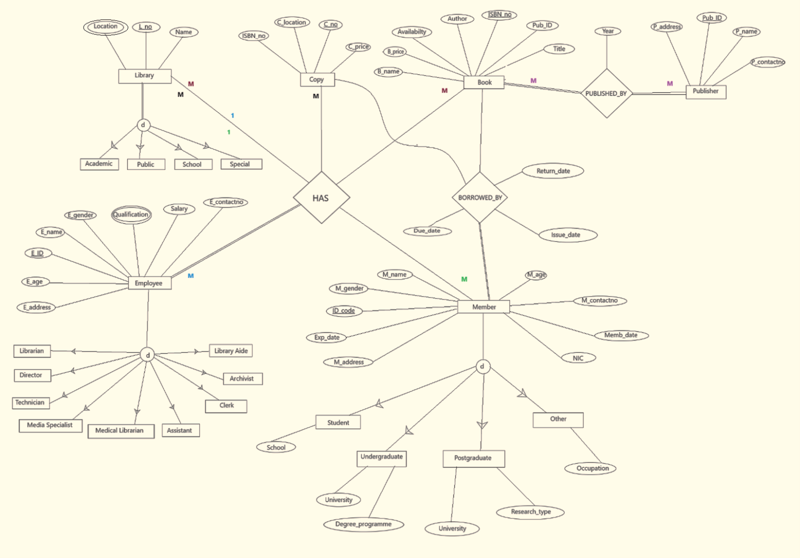

Figure 1: Enhanced Entity-Relationship Diagram

### Assumption

* This library service system has generalized into four branch libraries named as Academic, Public, School and Special.
* ISBN_no in the copy entity is the Foreign Key of the copy entity.
* Pub_ID in the book entity is the Foreign Key of the book entity.
* Qualification attribute under employee entity is a multi-valued attribute. Employees have been generalized into nine positions.
* Location attribute under Library entity is a multi-valued attribute.
* Members have been generalized into four categories named as student, undergraduate, postgraduate and others. As a library service system this is very easy for us to provide what each member needs.

## Relational Mapping Diagram

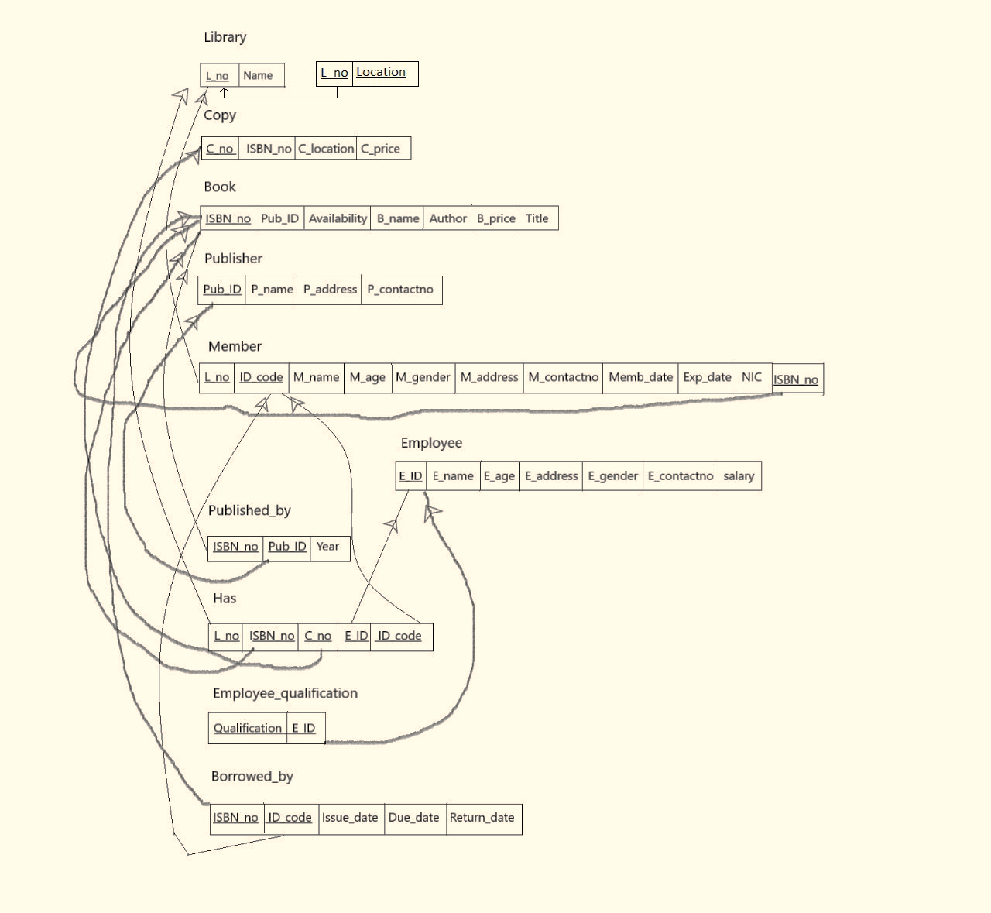

Figure 2: Relational Mapping Diagram

## Normalization

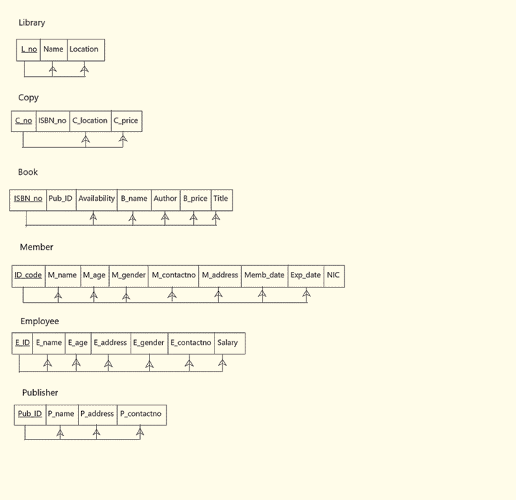

Figure 3: Normalization Diagram

## Data Dictionary

Library

|  |  |  |  |  |
| --- | --- | --- | --- | --- |
| P/F | Field Name | Description | Data Type | Field Size |
| P | L_no | Each library has a unique number  E.g., Main Library = 01 | Varchar(50) | 2 |
|  | Name | Name of each library | Varchar(80) | 15 |
|  | Location | Location of each library and it is multi-valued attribute | Varchar(120) | 20 |

Table 1: Library

Copy

|  |  |  |  |  |
| --- | --- | --- | --- | --- |
| P/F | Field Name | Description | Data Type | Field Size |
| P | C_no | Each copy has a unique number | Varchar(50) | 5 |
| F | ISBN_no | Each book has a unique number | Varchar(50) | 5 |
|  | C_price | Price of each copy | Numeric(6,3) |  |
|  | C_location | Location of each copy | Varchar(50) | 20 |

Table 2: Copy

Book

|  |  |  |  |  |
| --- | --- | --- | --- | --- |
| P/F | Field Name | Description | Data Type | Field Size |
| P | ISBN_no | Each book has a unique number | Varchar(50) | 5 |
| F | Pub_ID | Each publisher has a unique ID | Varchar(50) | 3 |
|  | B_name | Name of each book | Varchar(50) | 20 |
|  | Author | Author of each book | Varchar(50) | 15 |
|  | B_price | Price of each book | Numeric(6,3) | 6 |
|  | Title | Title of each book | Varchar(80) | 15 |
|  | Availability | Whether the book is available or not | bit | 10 |

Table 3: Book

Member

|  |  |  |  |  |
| --- | --- | --- | --- | --- |
| P/F | Field Name | Description | Data Type | Field Size |
| P | ID code | Unique number for each member | Varchar(50) | 05 |
|  | M_name | Name of each member | Varchar(80) | 20 |
|  | M_age | Age of each member | Integer | 02 |
|  | M_gender | Gender of each member (Male/Female) | Varchar(10) | 05 |
|  | M_contactno | Contact number of each member | Varchar(120) | 10 |
|  | M_address | Address of each member | Varchar(50) | 20 |
|  | Memb_date | Start date of membership | date |  |
|  | Exp_date | Expiry date of membership | date |  |
|  | NIC | National Identity Card number of each member | Numeric(10) | 10 |

Table 4: Member

Employee

|  |  |  |  |  |
| --- | --- | --- | --- | --- |
| P/F | Field Name | Description | Data Type | Field Size |
| P | E_ID | Unique ID number for each Employee | Varchar(50) | 05 |
|  | E_Name | Name of each Employee | Varchar(80) | 20 |
|  | E_age | Age of each Employee | Integer | 02 |
|  | E_address | Address of each Employee | Varchar(120) | 20 |
|  | E_gender | Gender of each Employee (Male/Female) | Varchar(10) | 05 |
|  | E_Contactno | Contact number of each Employee | Varchar(10) | 10 |
|  | Salary | Salary of each Employee | Numeric(6,3) | 06 |
|  | Qualification | Qualifications of each Employee, this can be multi-valued | Varchar(50) | 30 |

Table 5: Employee

# Section 02

## Creating Table

1. Library

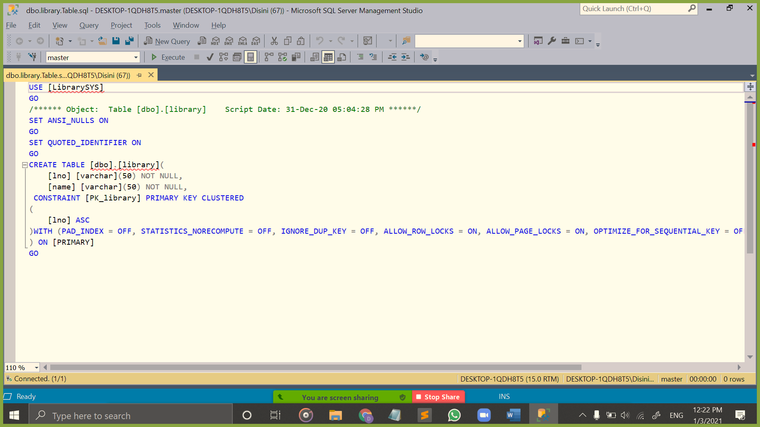

Figure 4: Library (Create Code)

1. Library Location

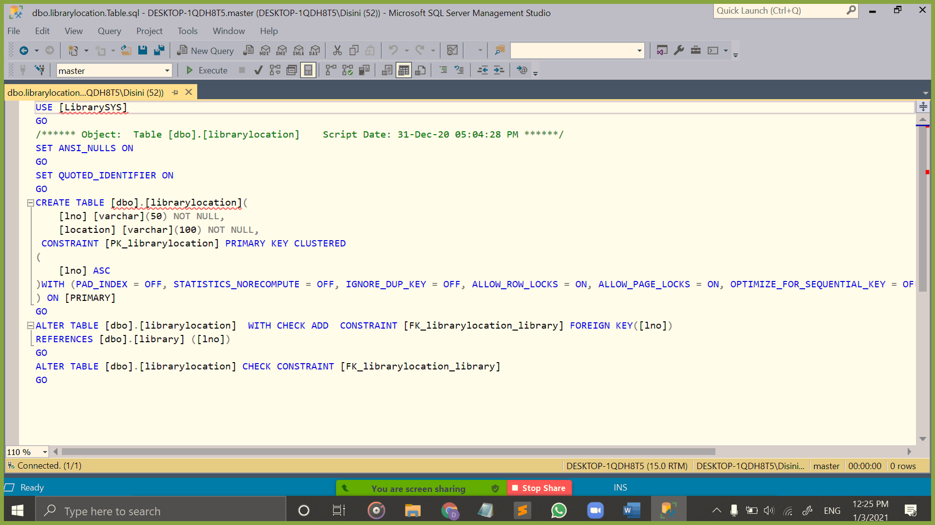

Figure 5: Library Location (Create Code)

1. Academic

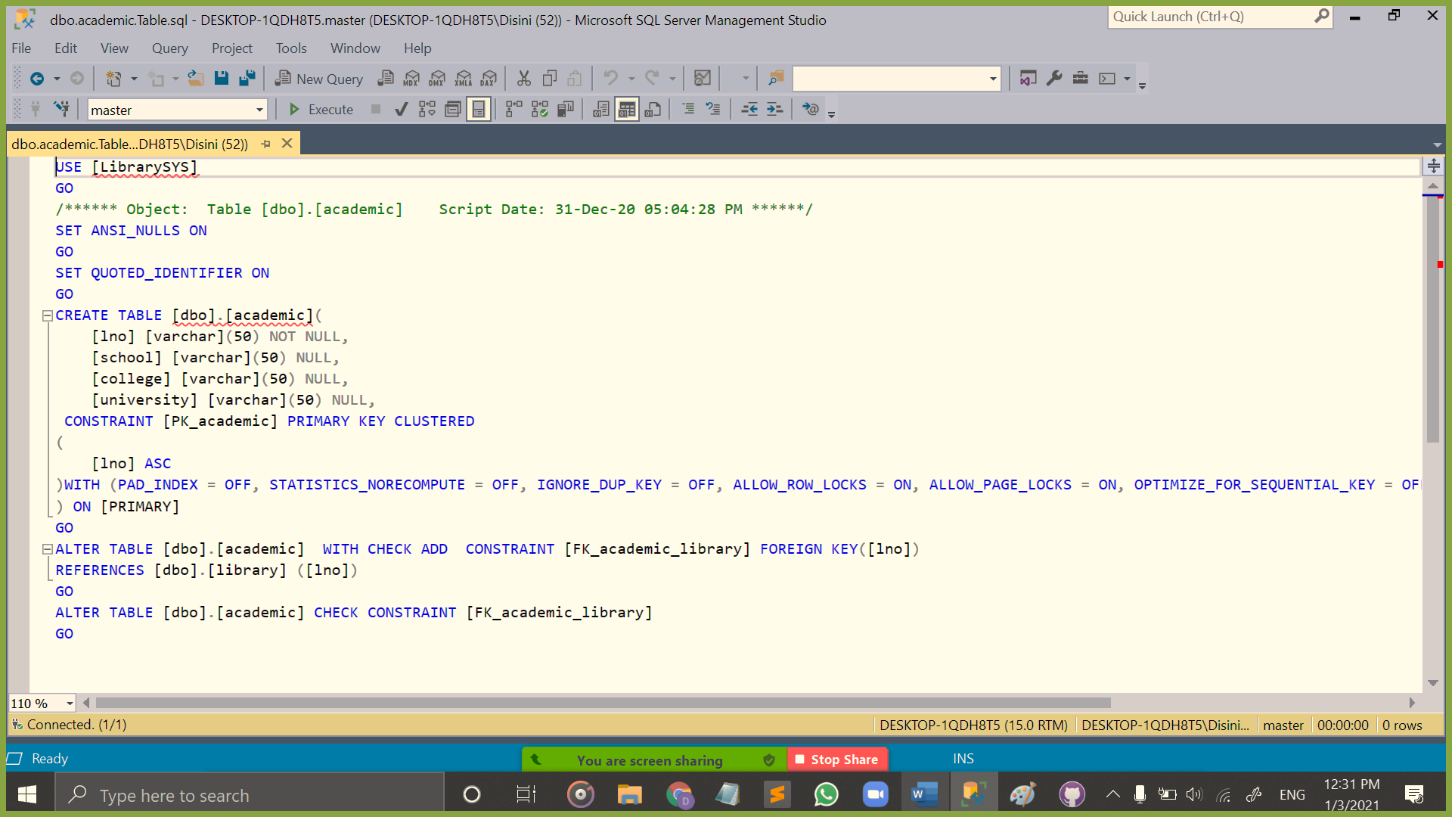

Figure 6: Library Academic (Create Code)

1. Public

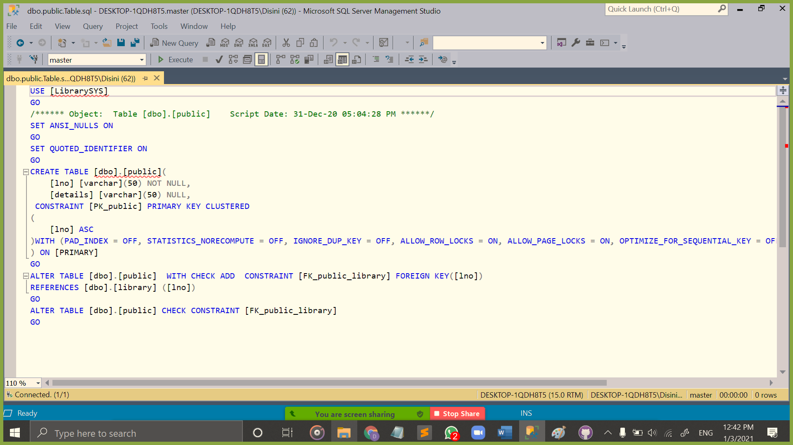

Figure 7: Library Special (Create Code)

1. Special

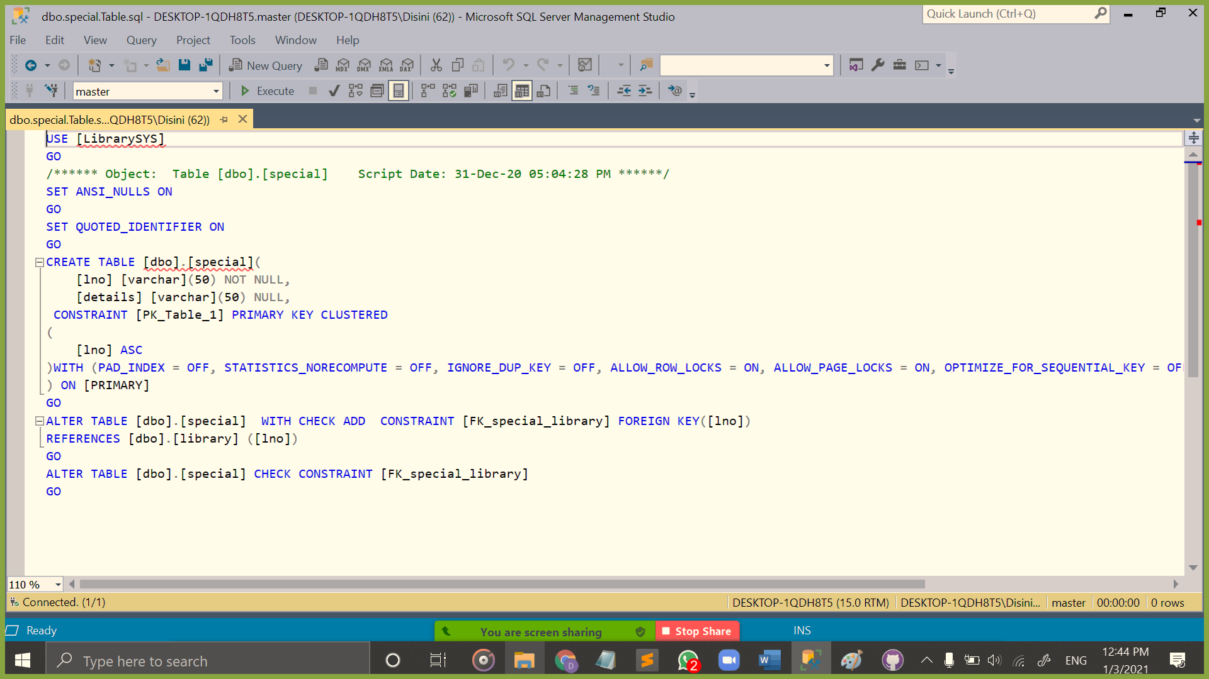

Figure 8: Library Special (Create Code)

1. Employee

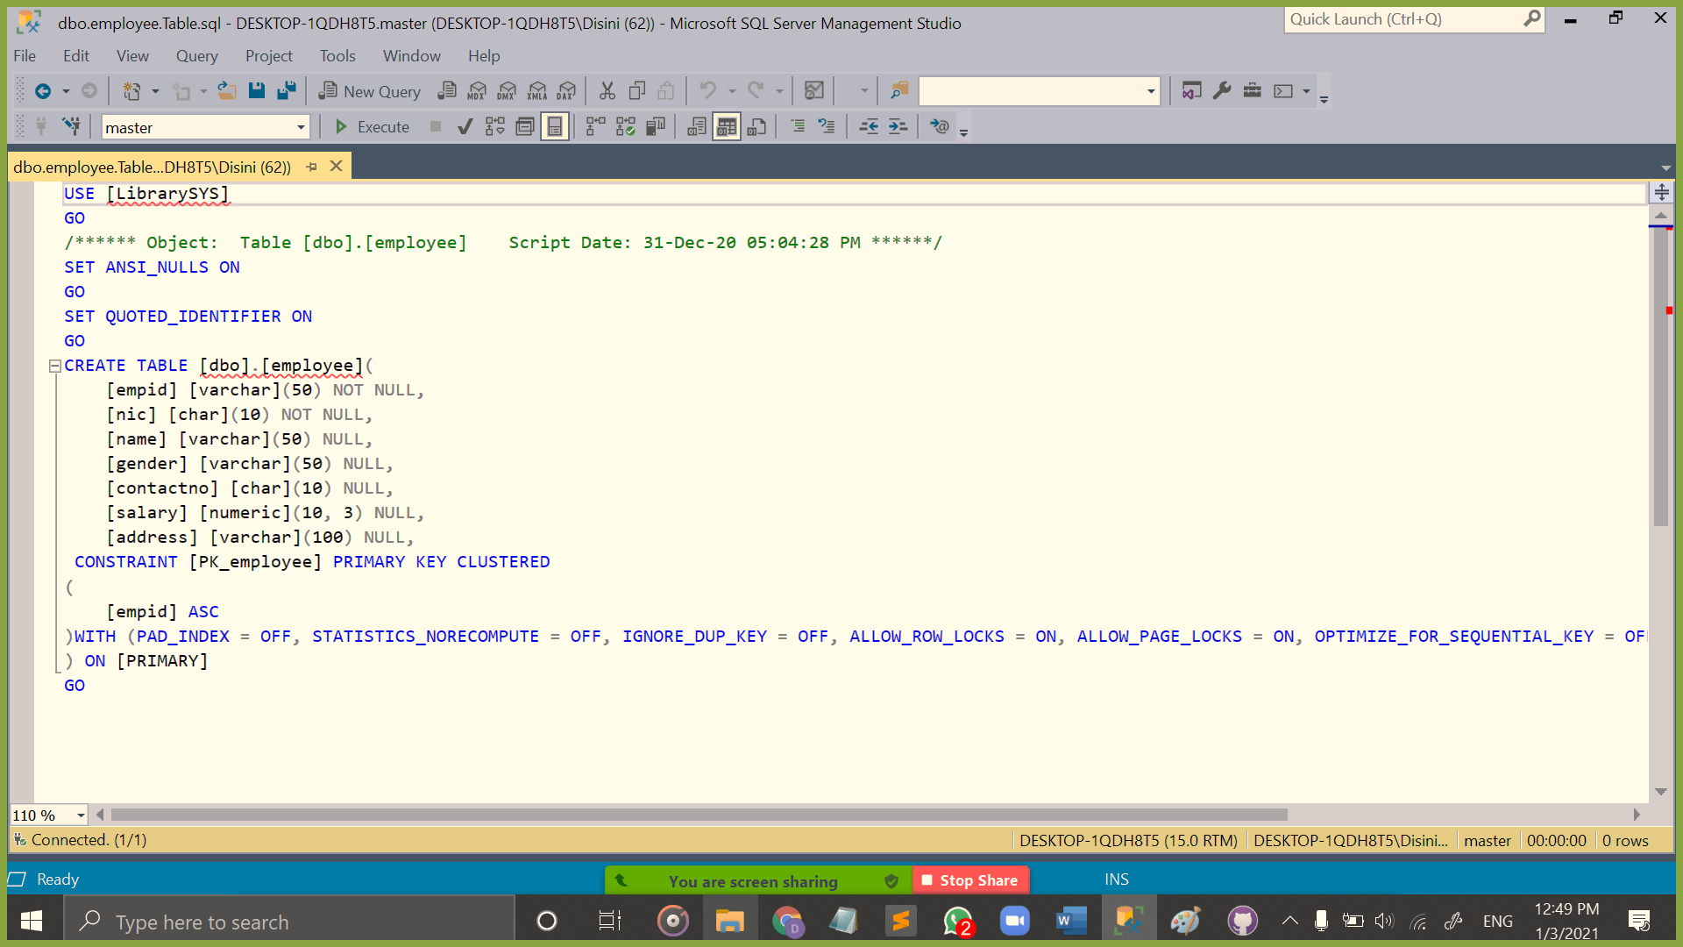

Figure 9: Employee (Create Code)

1. Employee Qualification

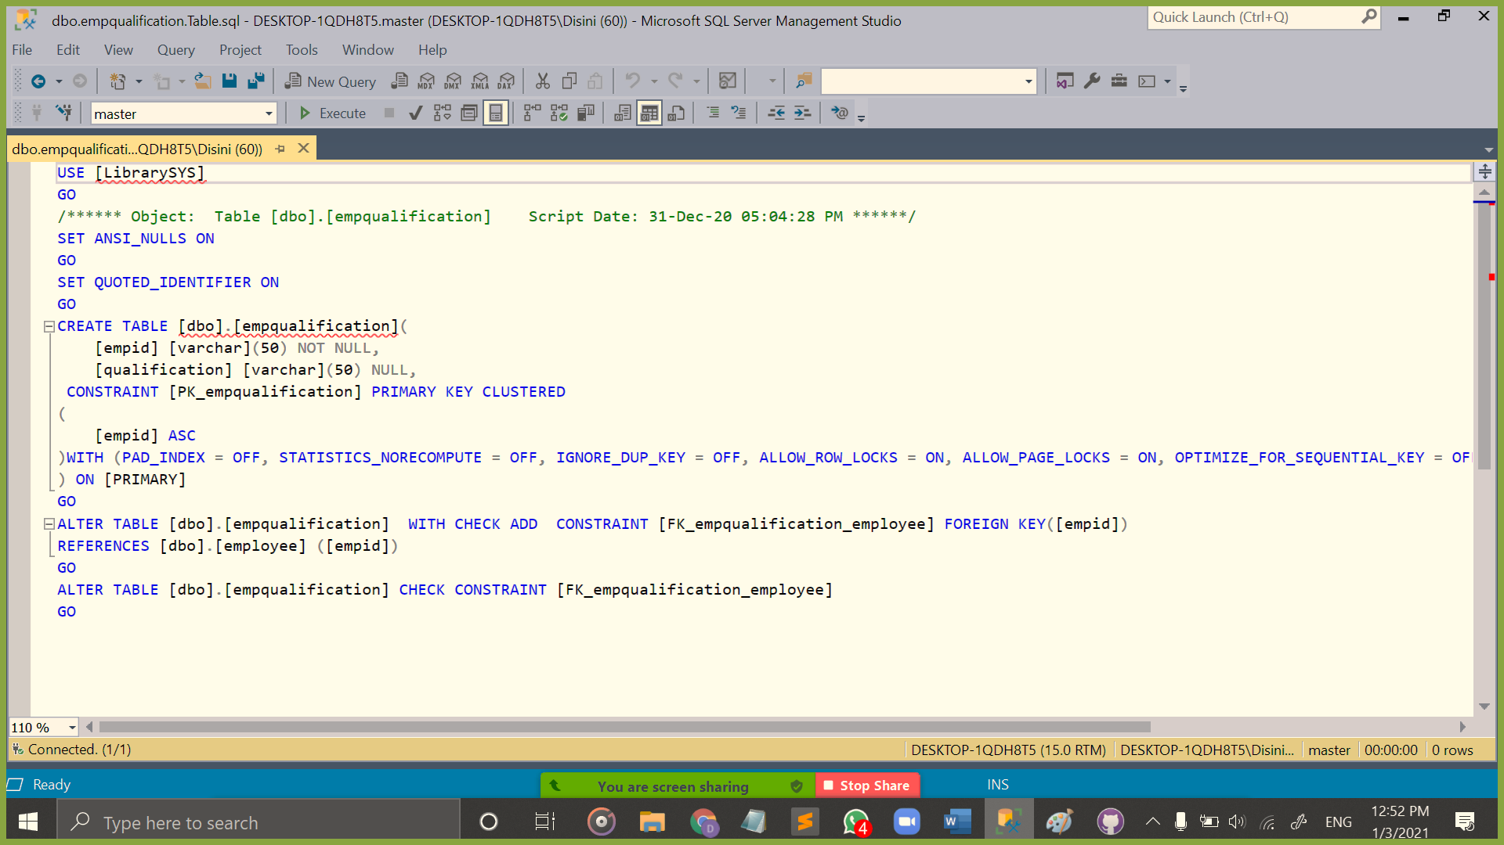

Figure 10: Employee Qualification (Create Code)

1. Librarian

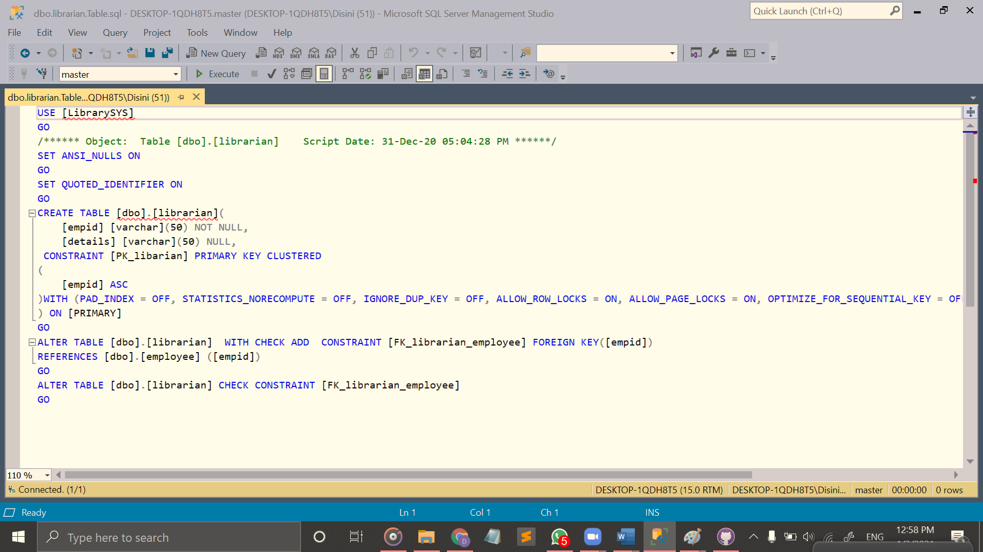

Figure 11: Employee Librarian (Create Code)

1. Director

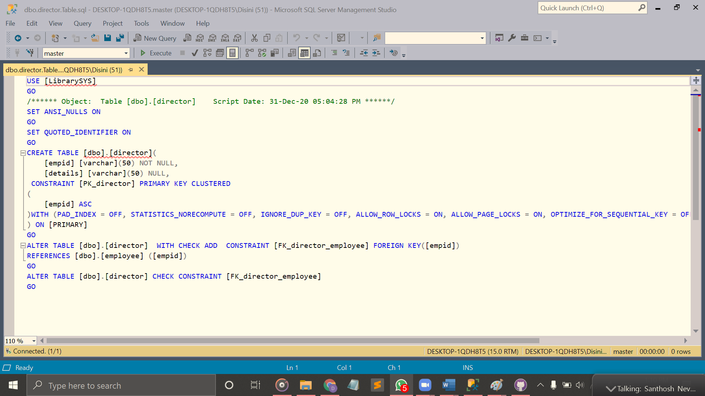

Figure 12: Employee Director (Create Code)

1. Medical Librarian

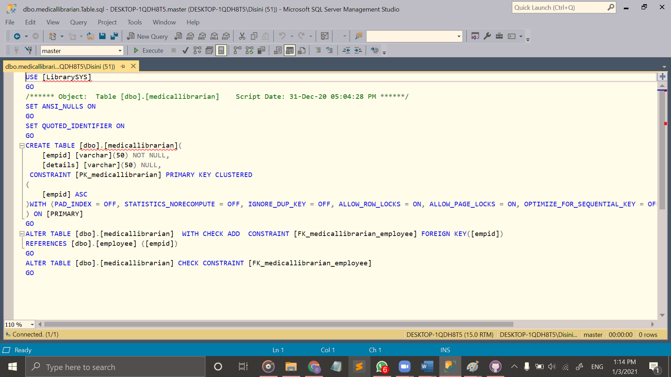

Figure 13: Employee Medical Librarian (Create Code)

1. Medical Specialist

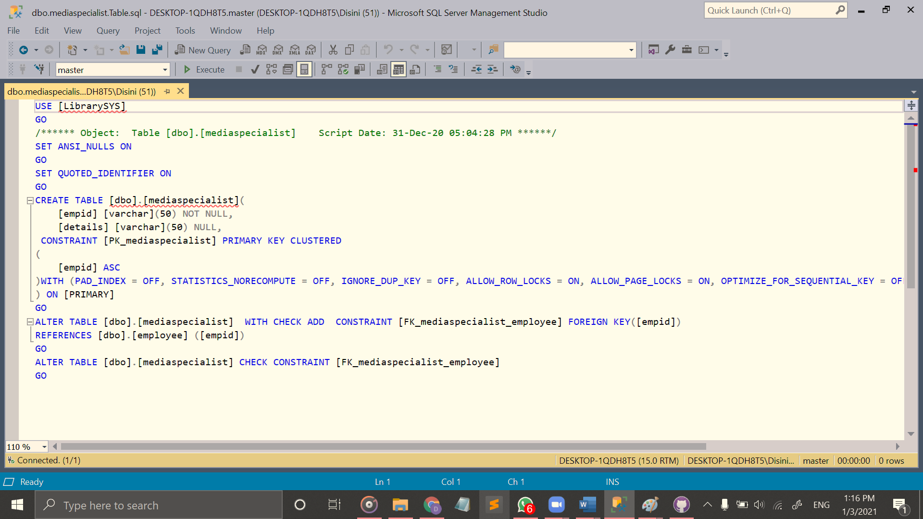

Figure 14: Employee Medical Specialist (Create Code)

1. Assistant

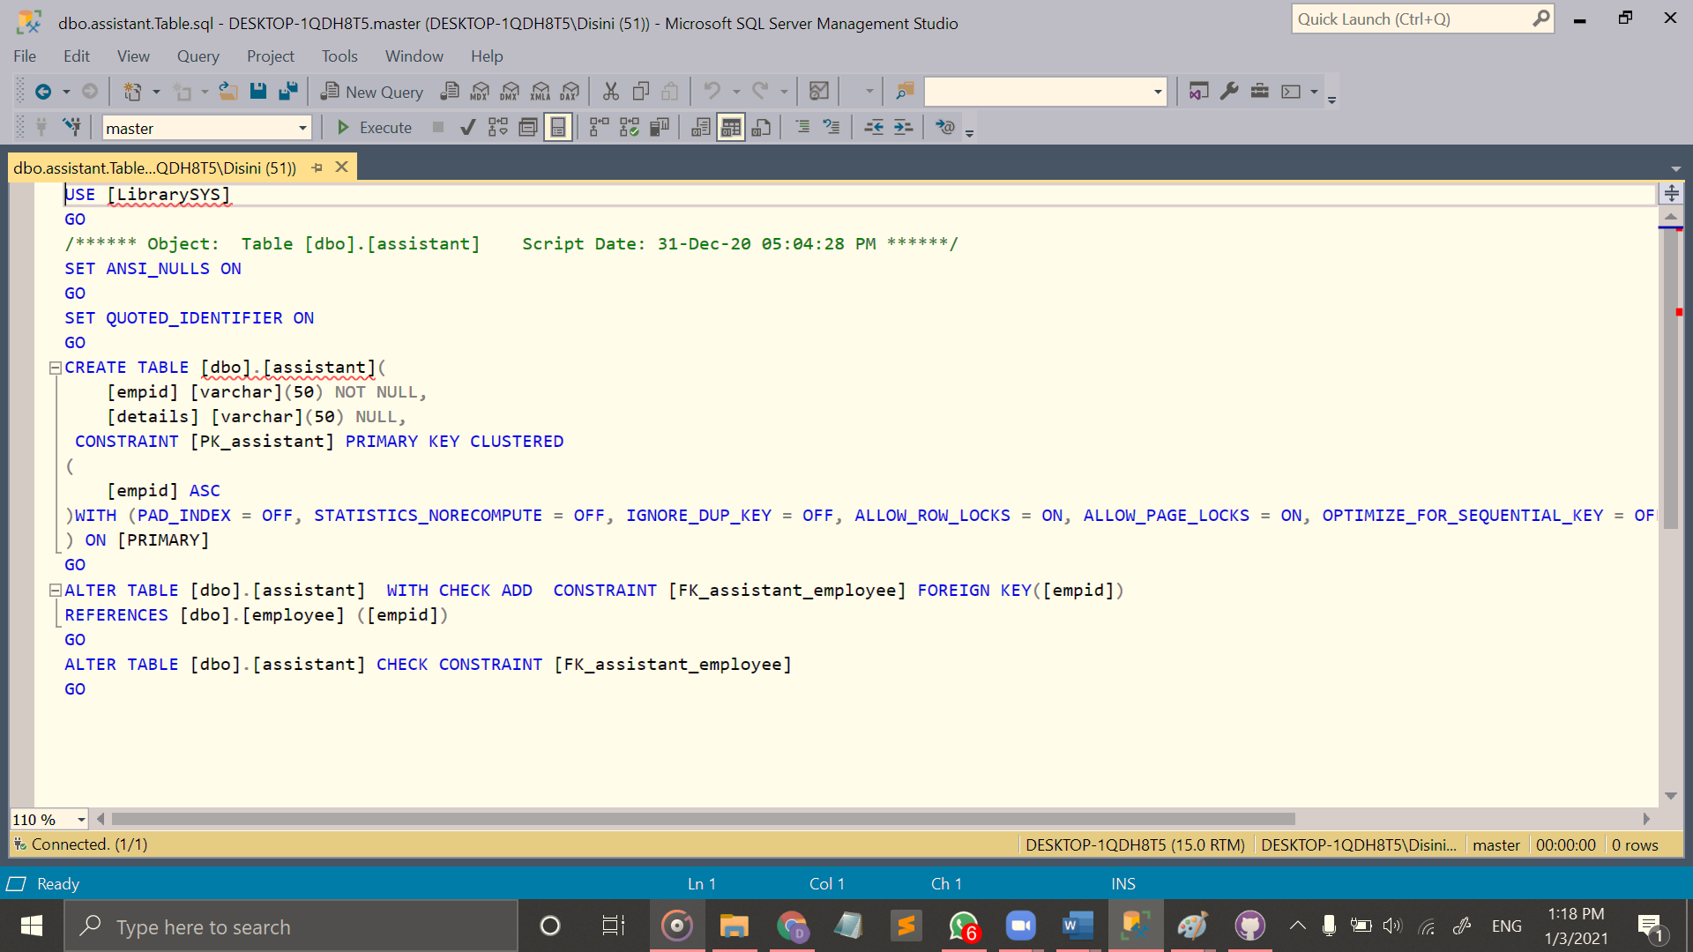

Figure 15: Employee Assistant (Create Code)

1. Library Aid

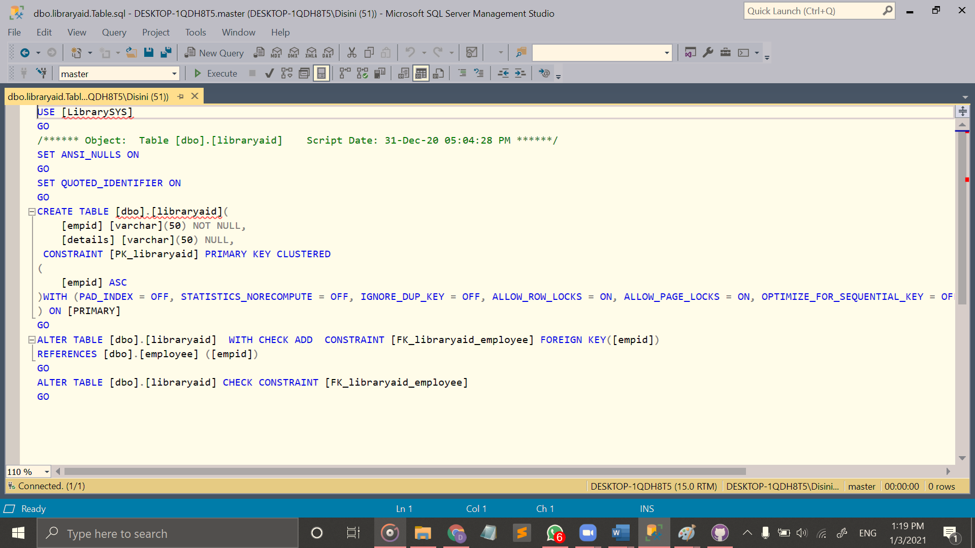

Figure 16: Employee Library Aid (Create Code)

1. Archivists

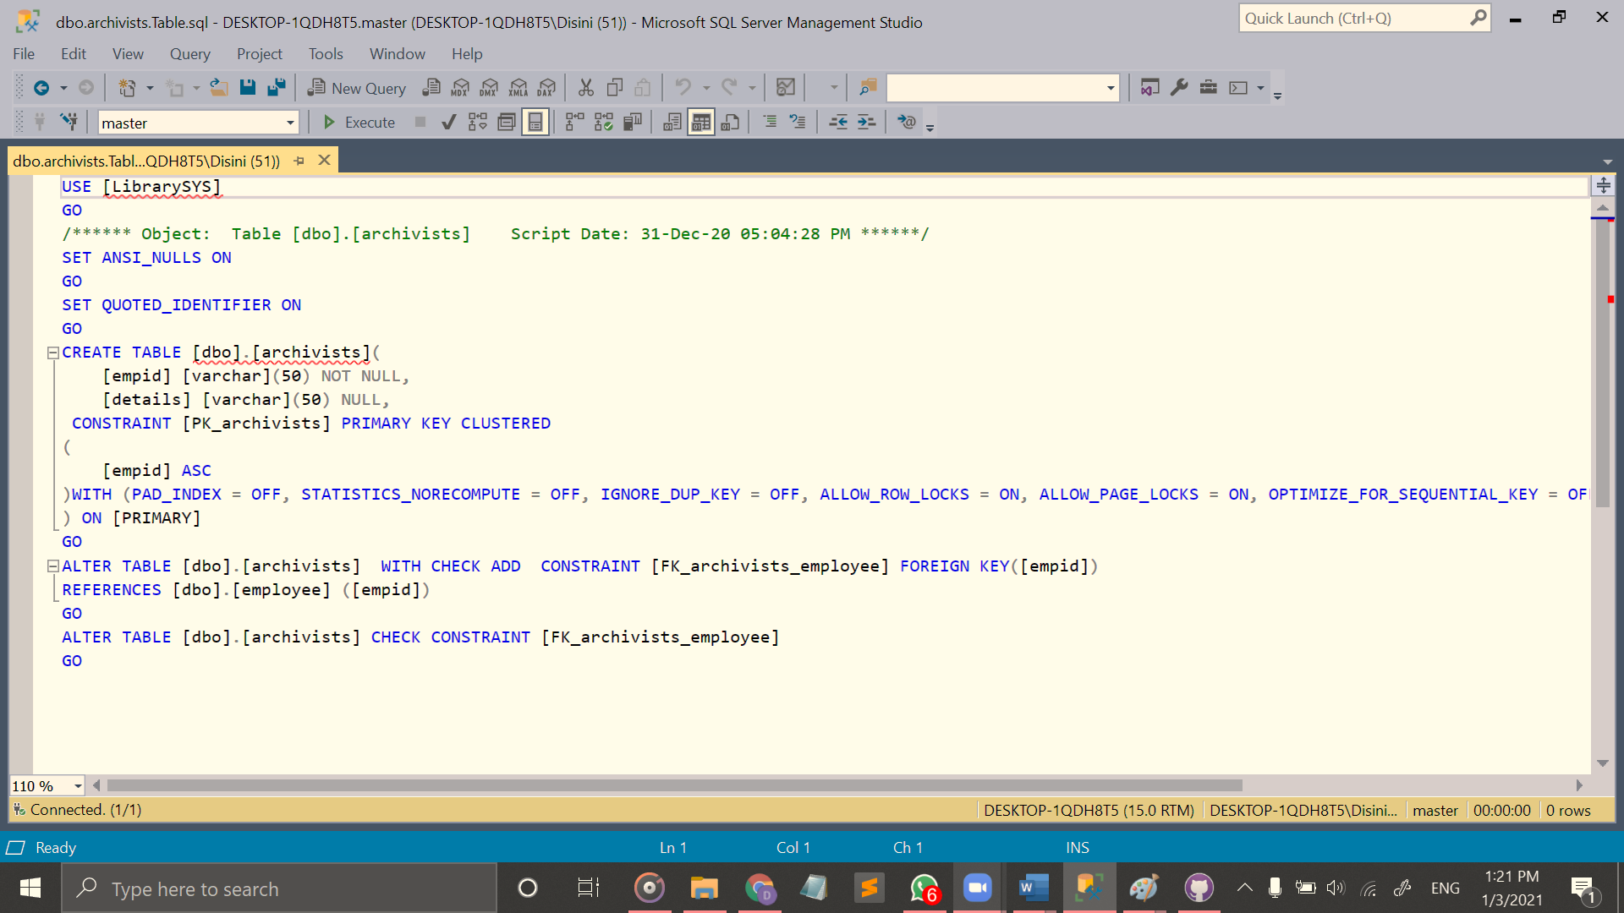

Figure 17: Employee Archivists (Create Code)

1. Technician

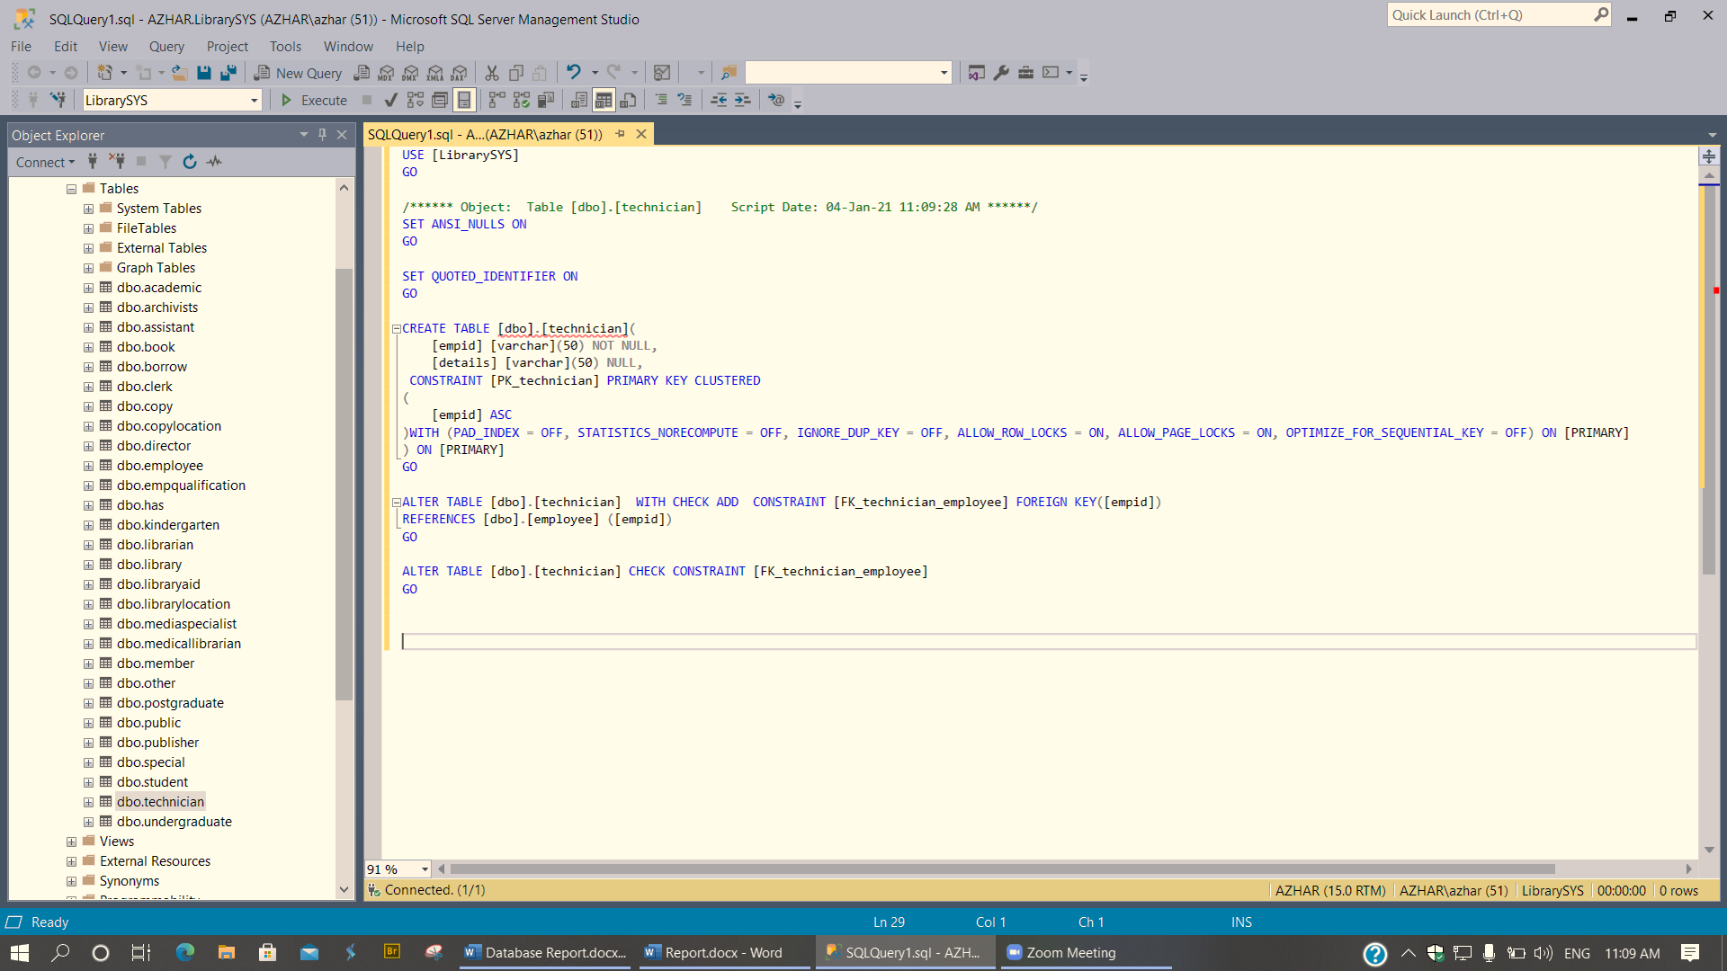

Figure 18: Employee Technician (Create Code)

1. Clerk

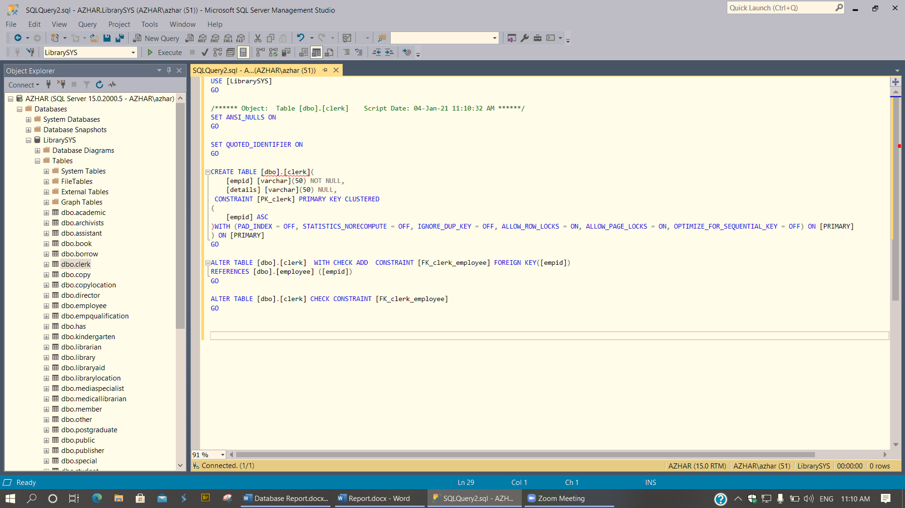

Figure 19: Employee Clerk (Create Code)

1. Publisher

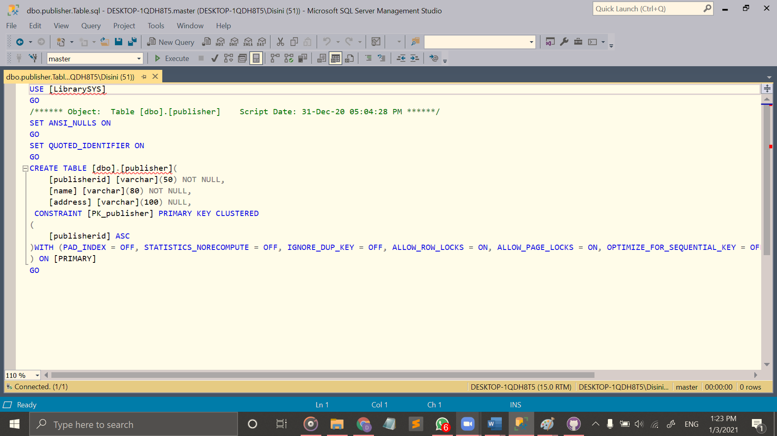

Figure 20: Employee Publisher (Create Code)

1. Book

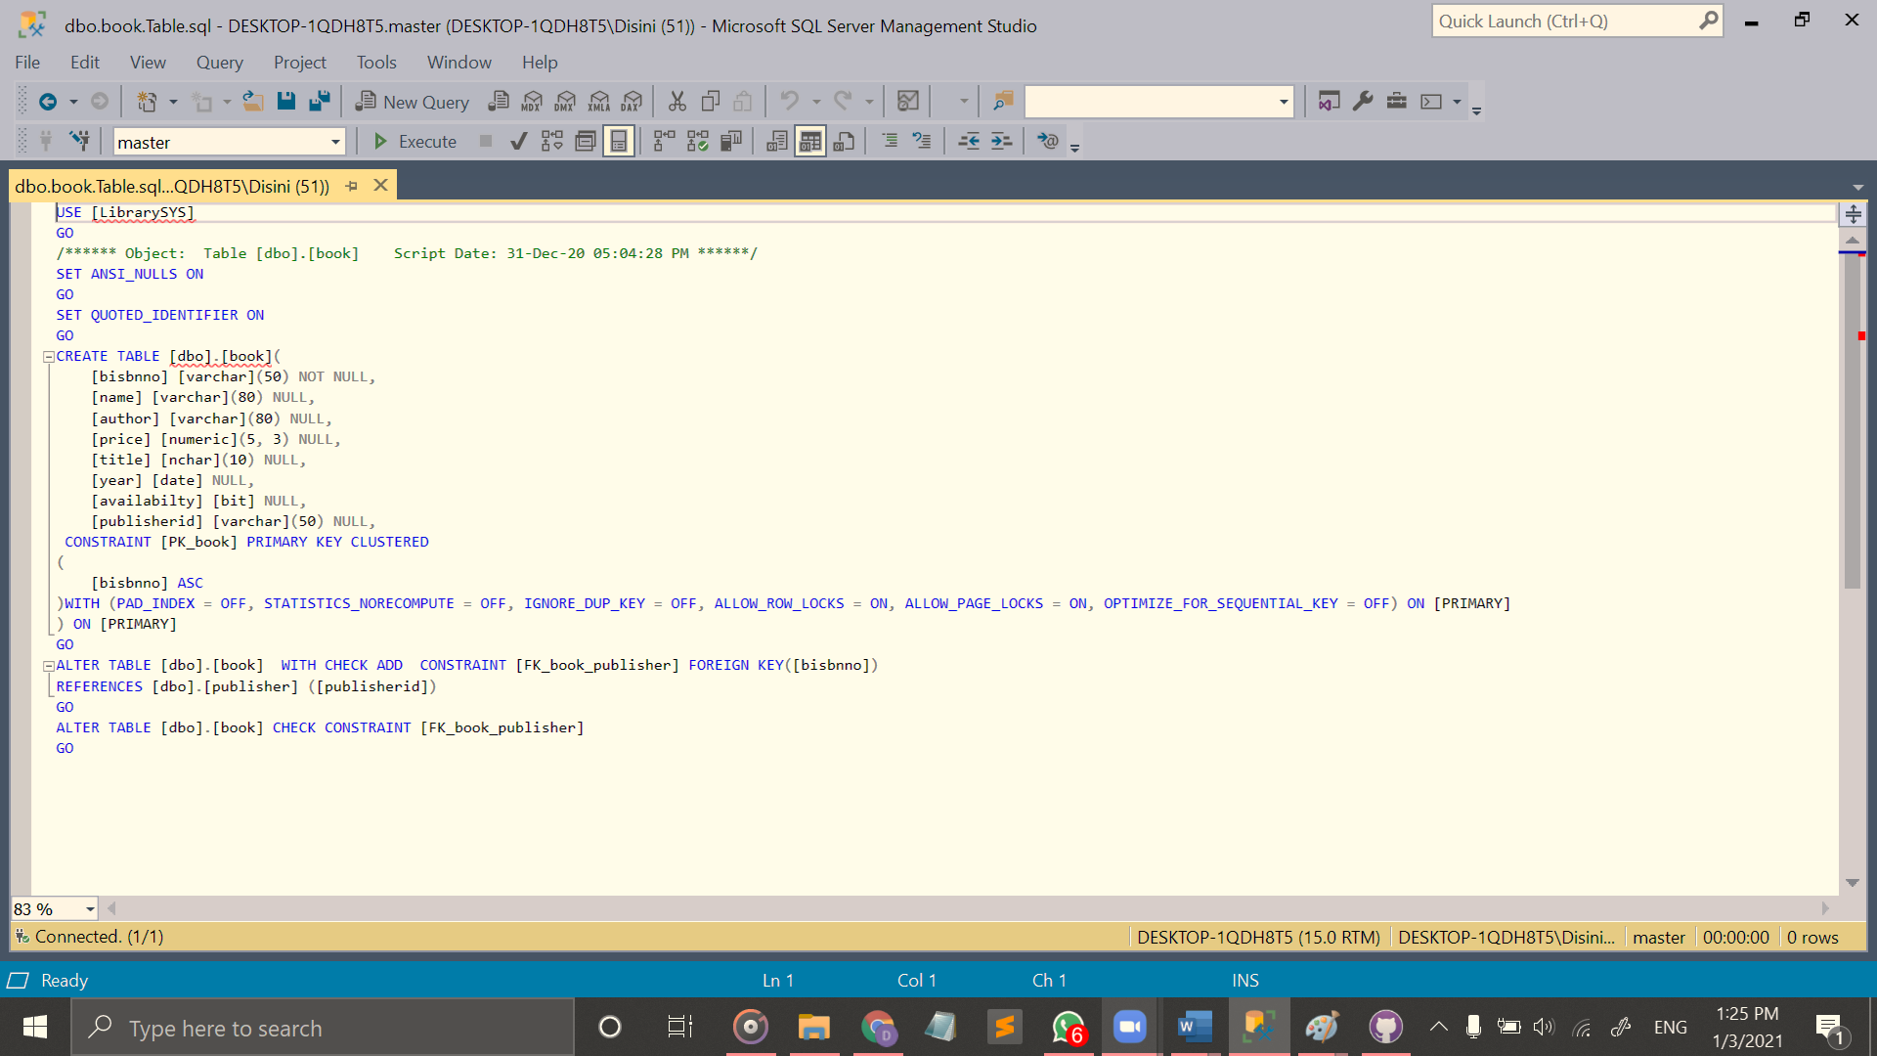

Figure 21:Book (Create Code)

1. Member

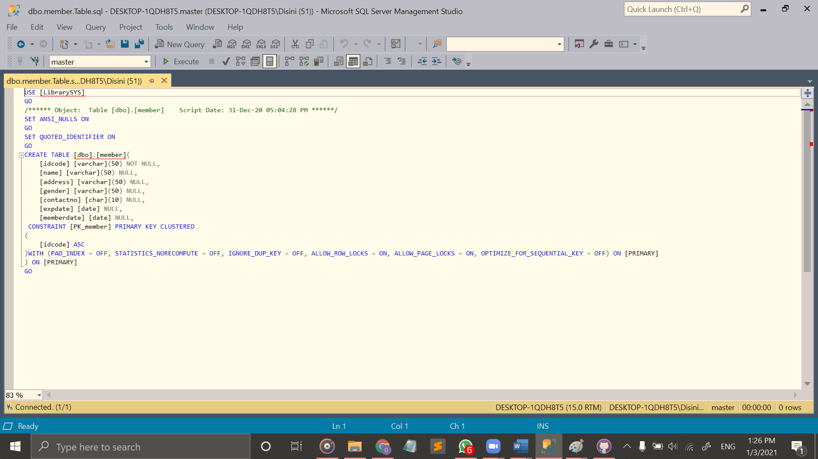

Figure 22: Member (Create Code)

1. Kindergarten

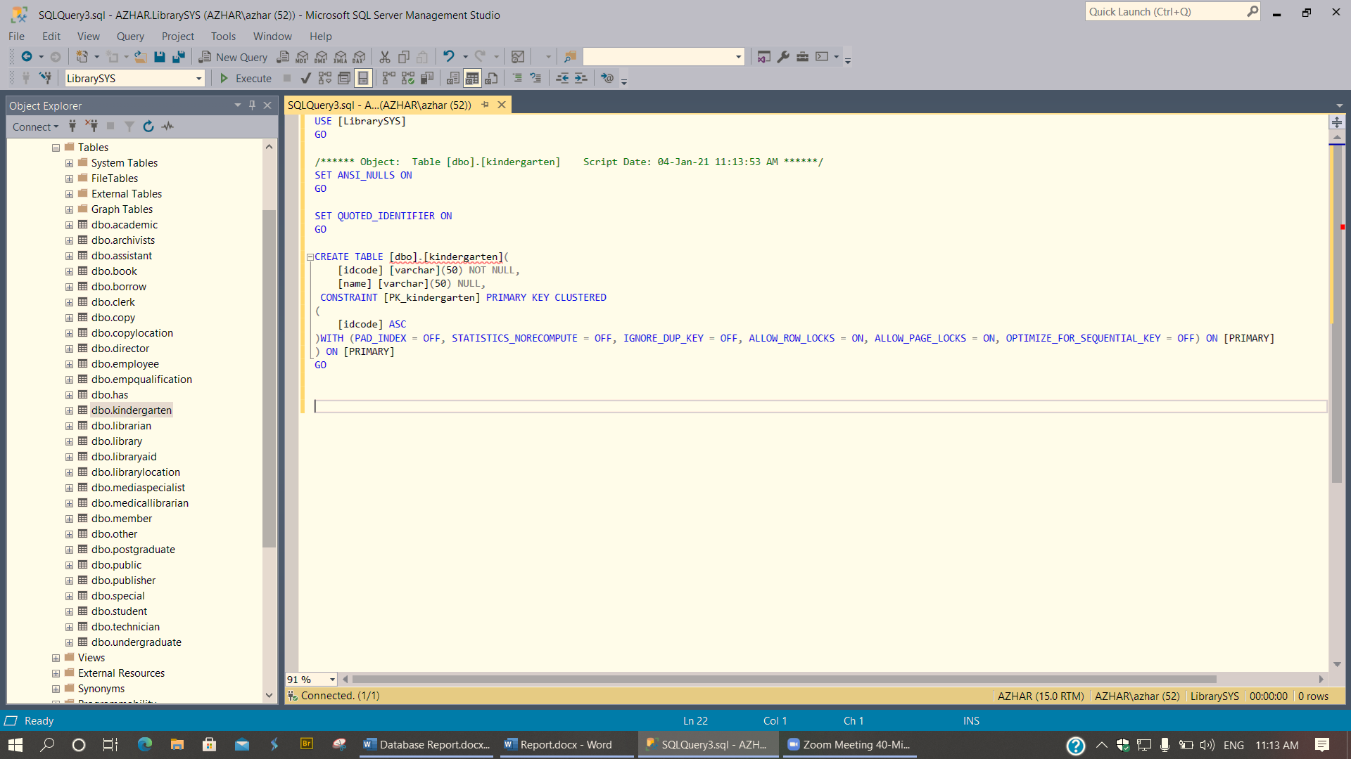

Figure 23: Member Kindergarten (Create Code)

1. Student

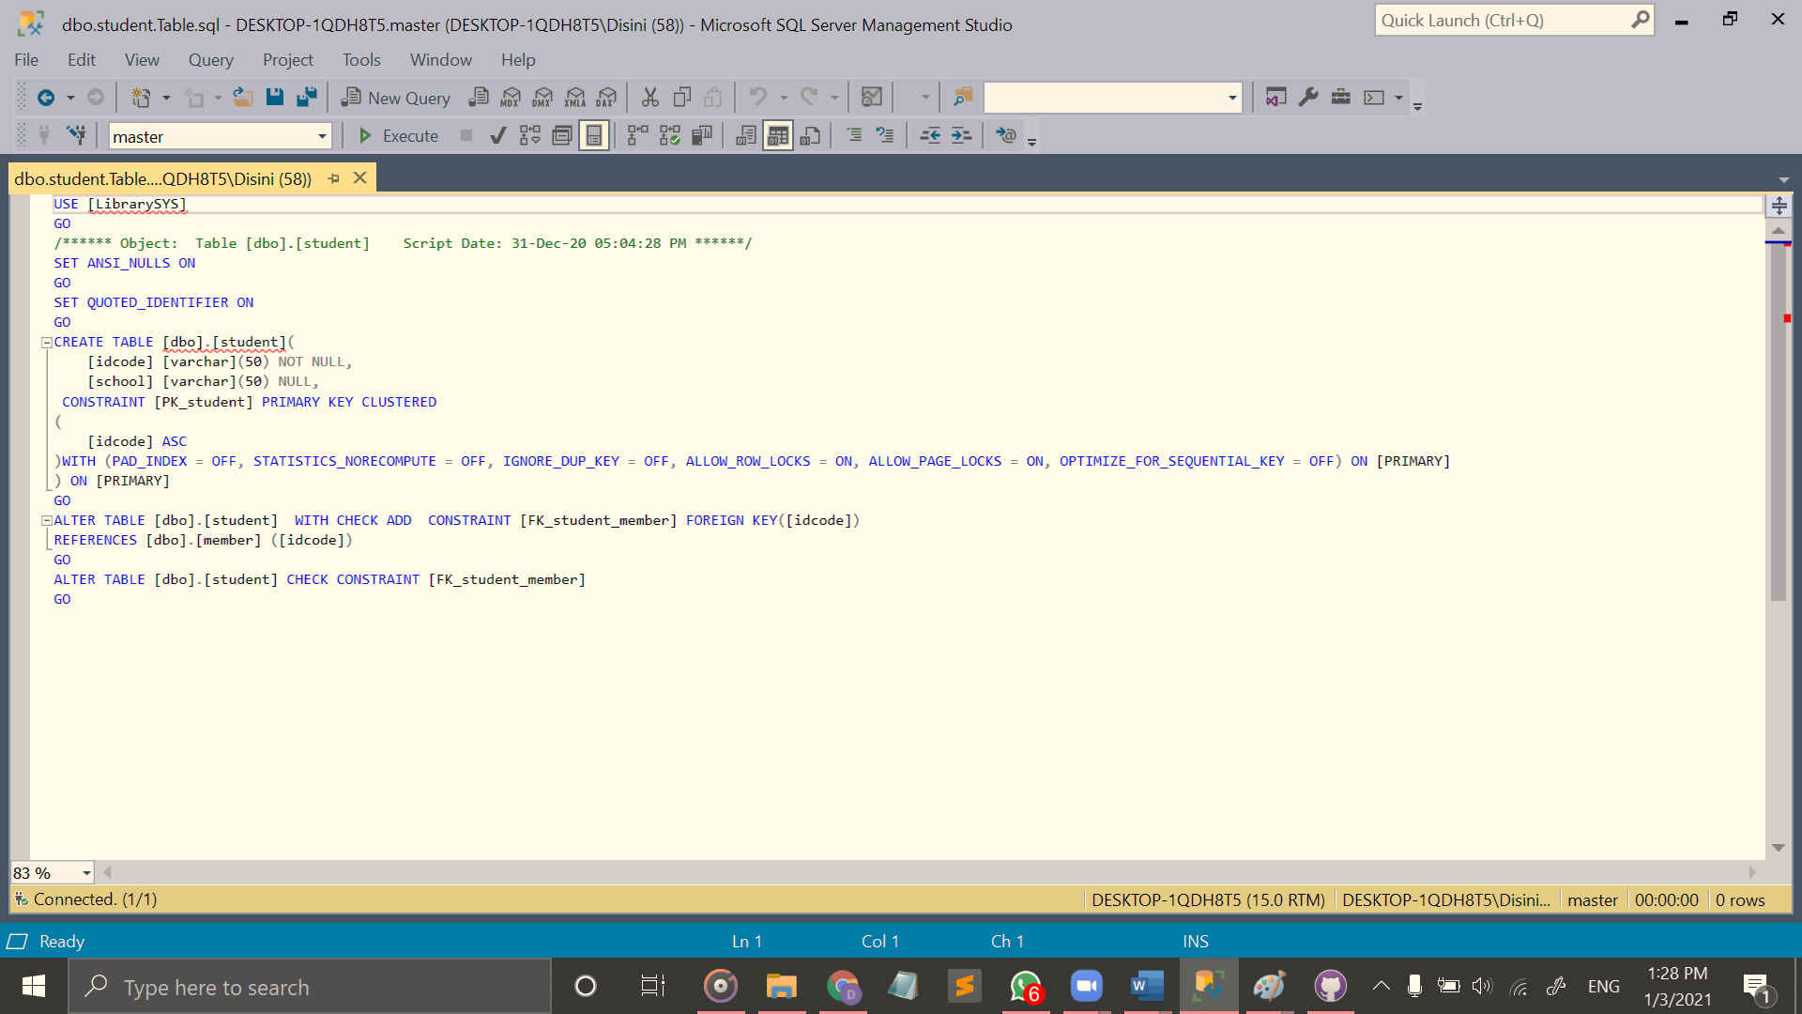

Figure 24: Member Student (Create Code)

1. Undergraduate

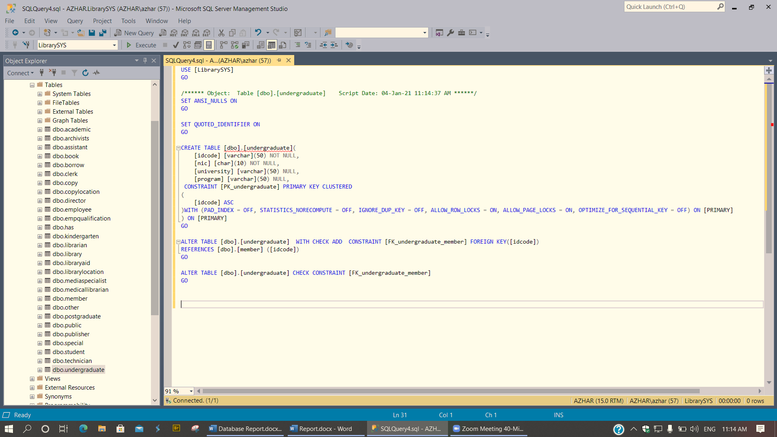

Figure 25: Member Undergraduate (Create Code)

1. Postgraduate

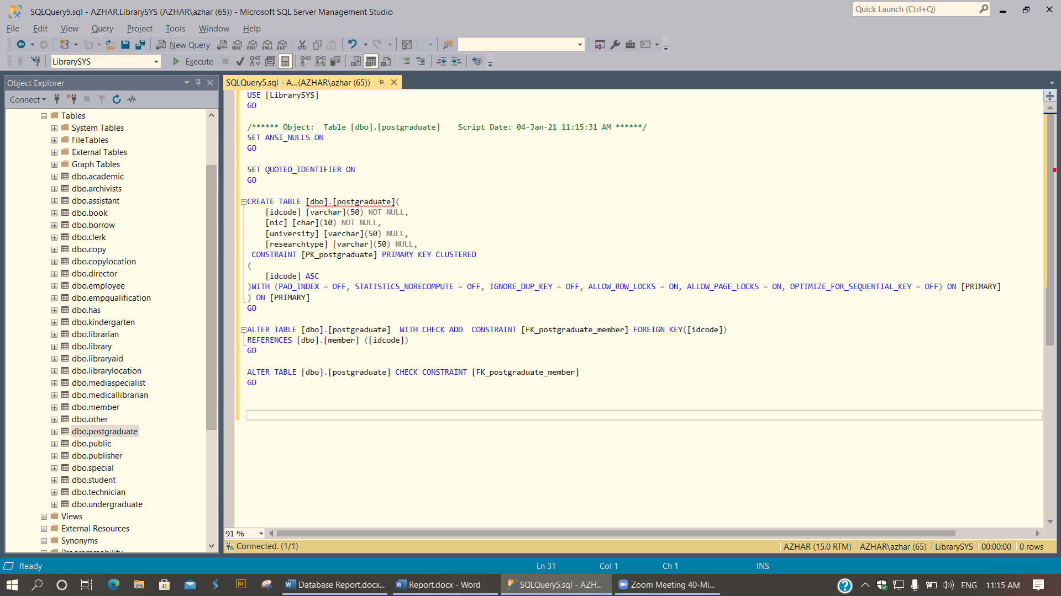

Figure 26: Member Postgraduate (Create Code)

1. Other

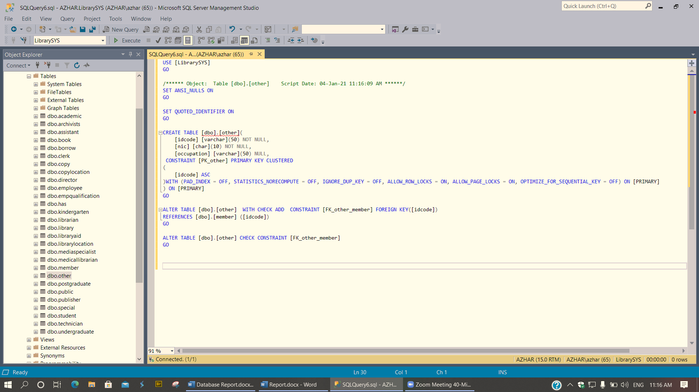

Figure 27: Member Other (Create Code)

1. Copy

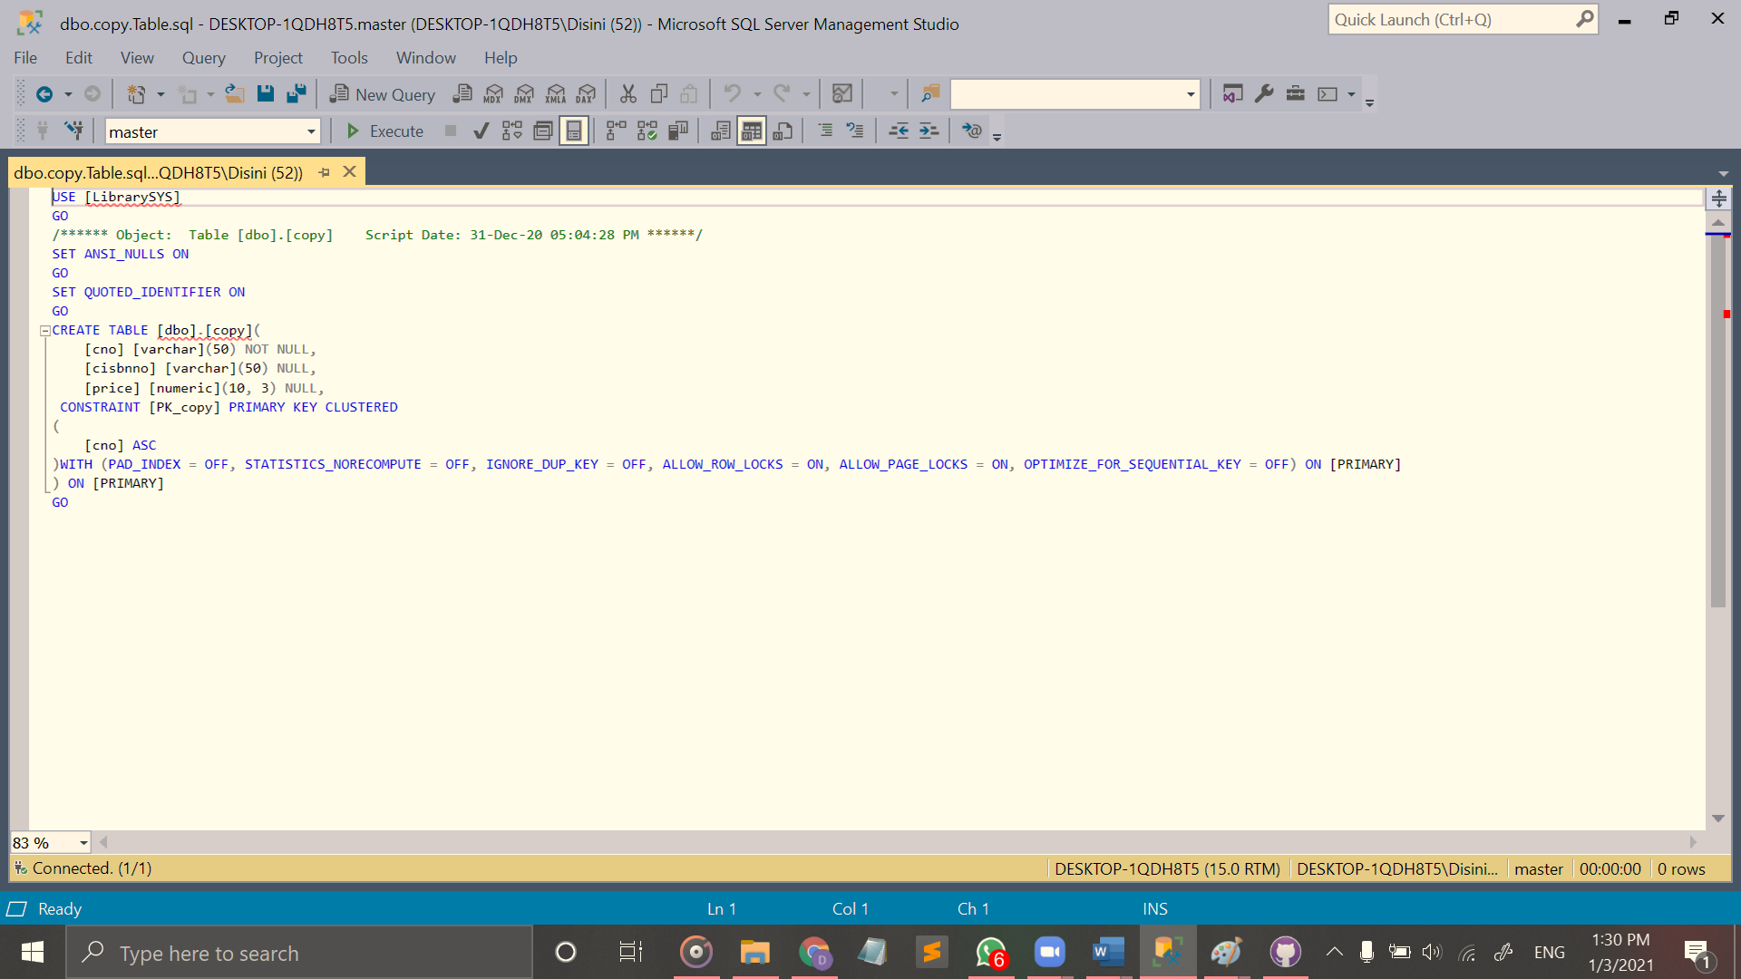

Figure 28: Copy (Create Code)

1. Copy Location

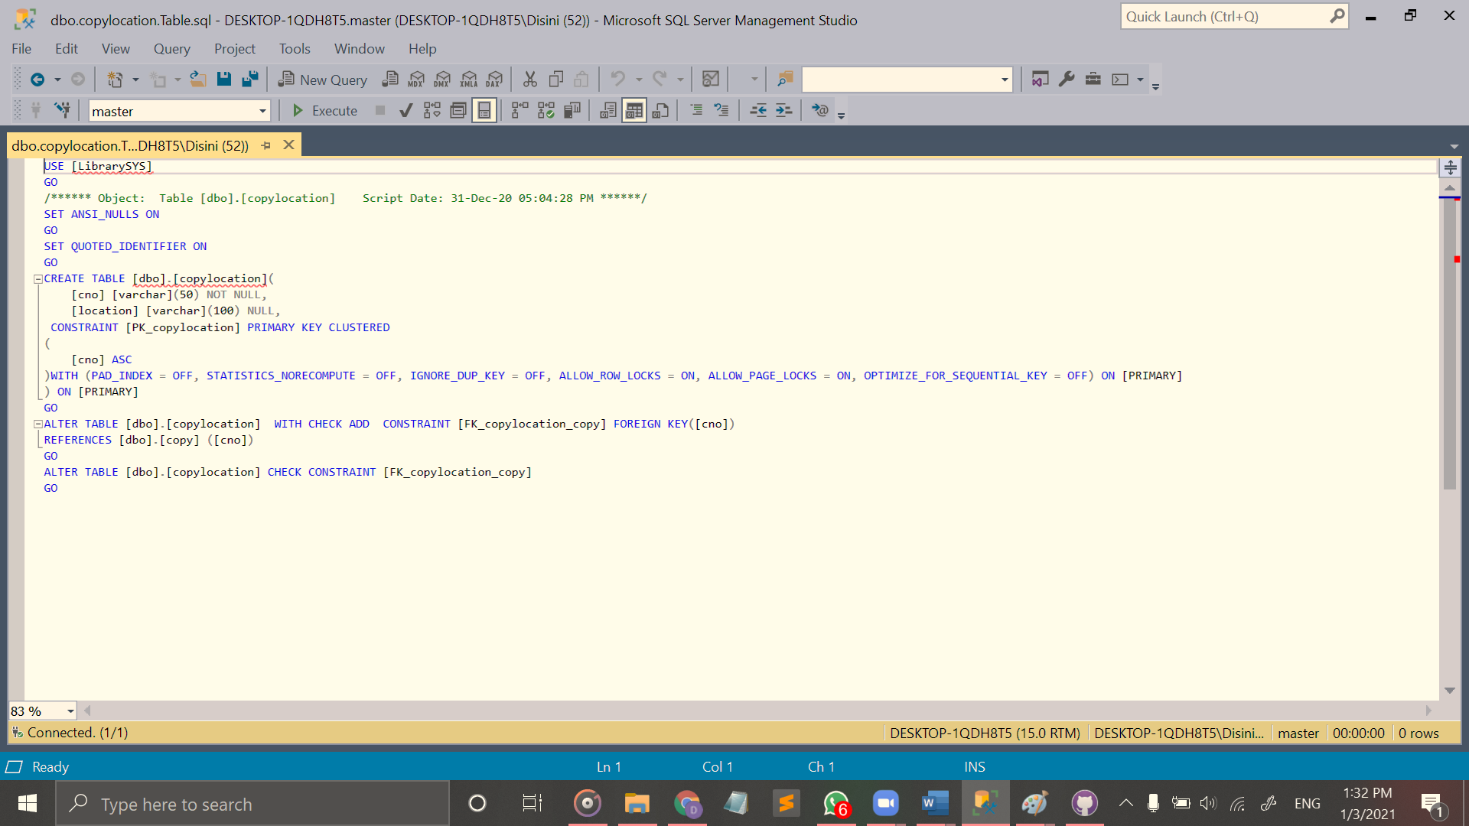

Figure 29: Copy Location (Create Code)

1. Has Relationship

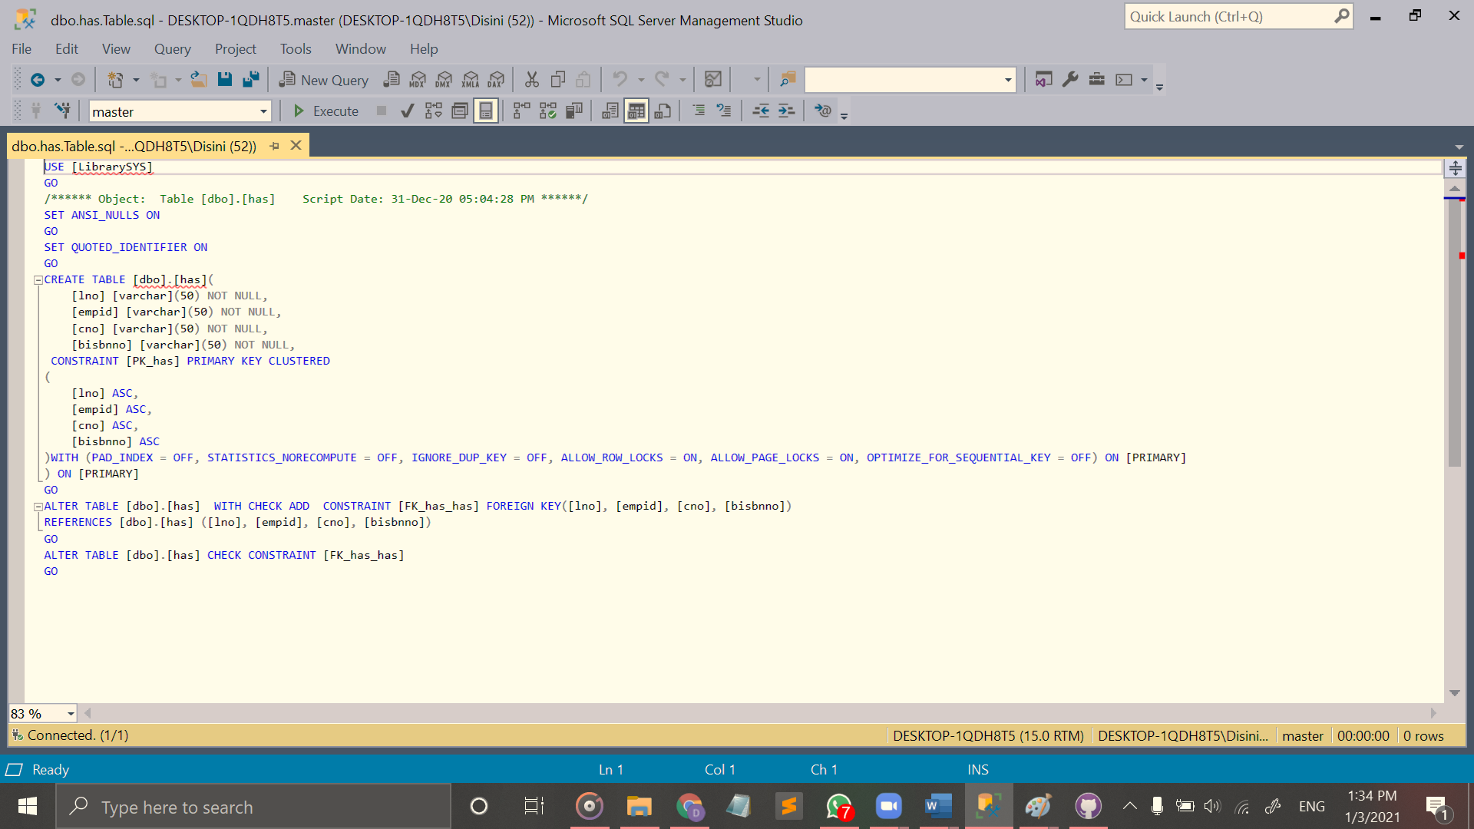

Figure 30: Has Relationship (Create Code)

1. Borrow relationship

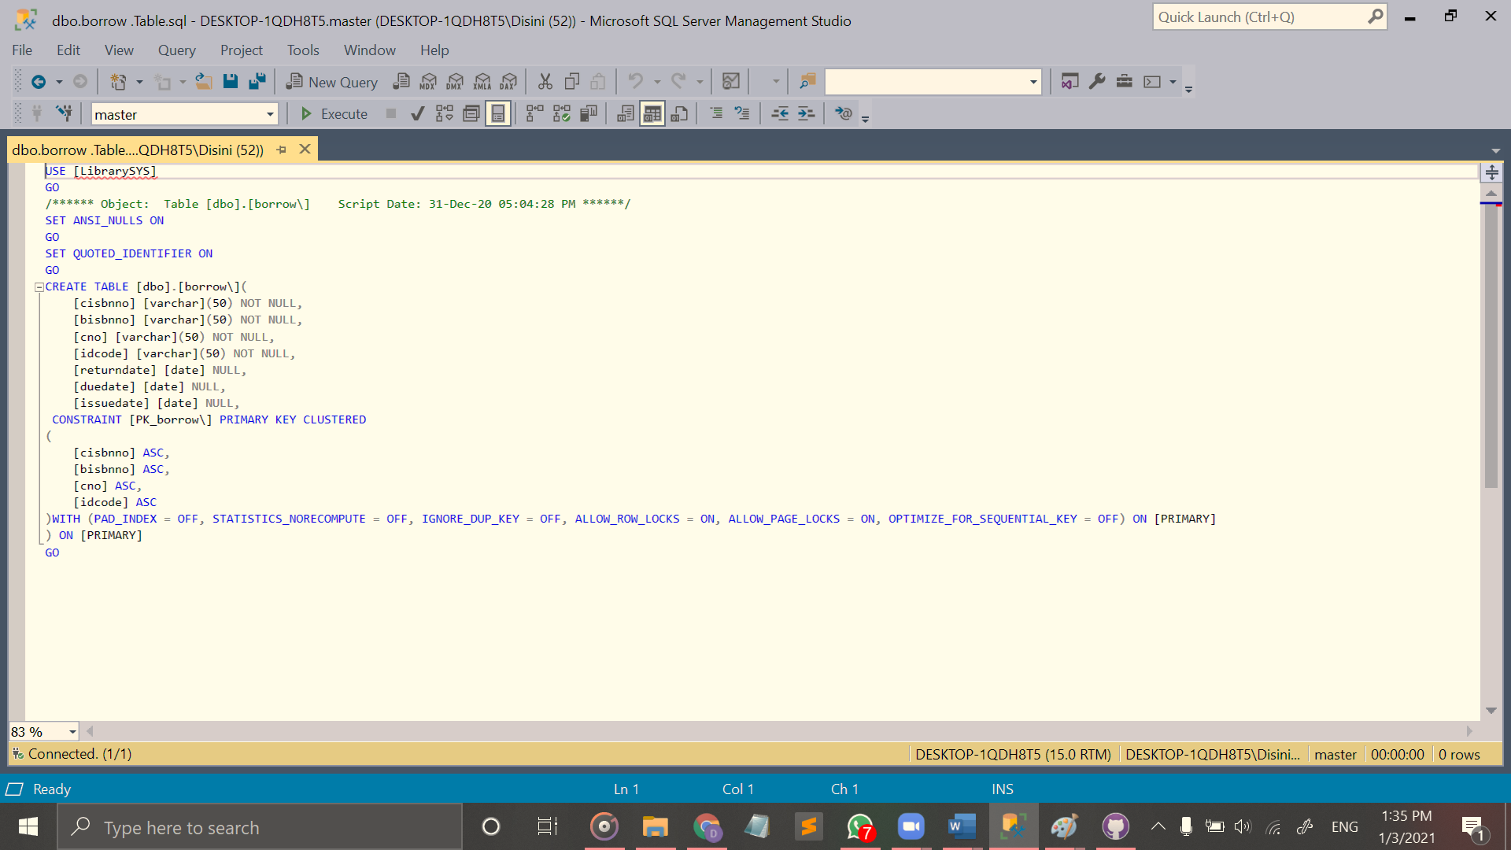

Figure 31: Borrow Relationship (Create Code)

## Database Diagram

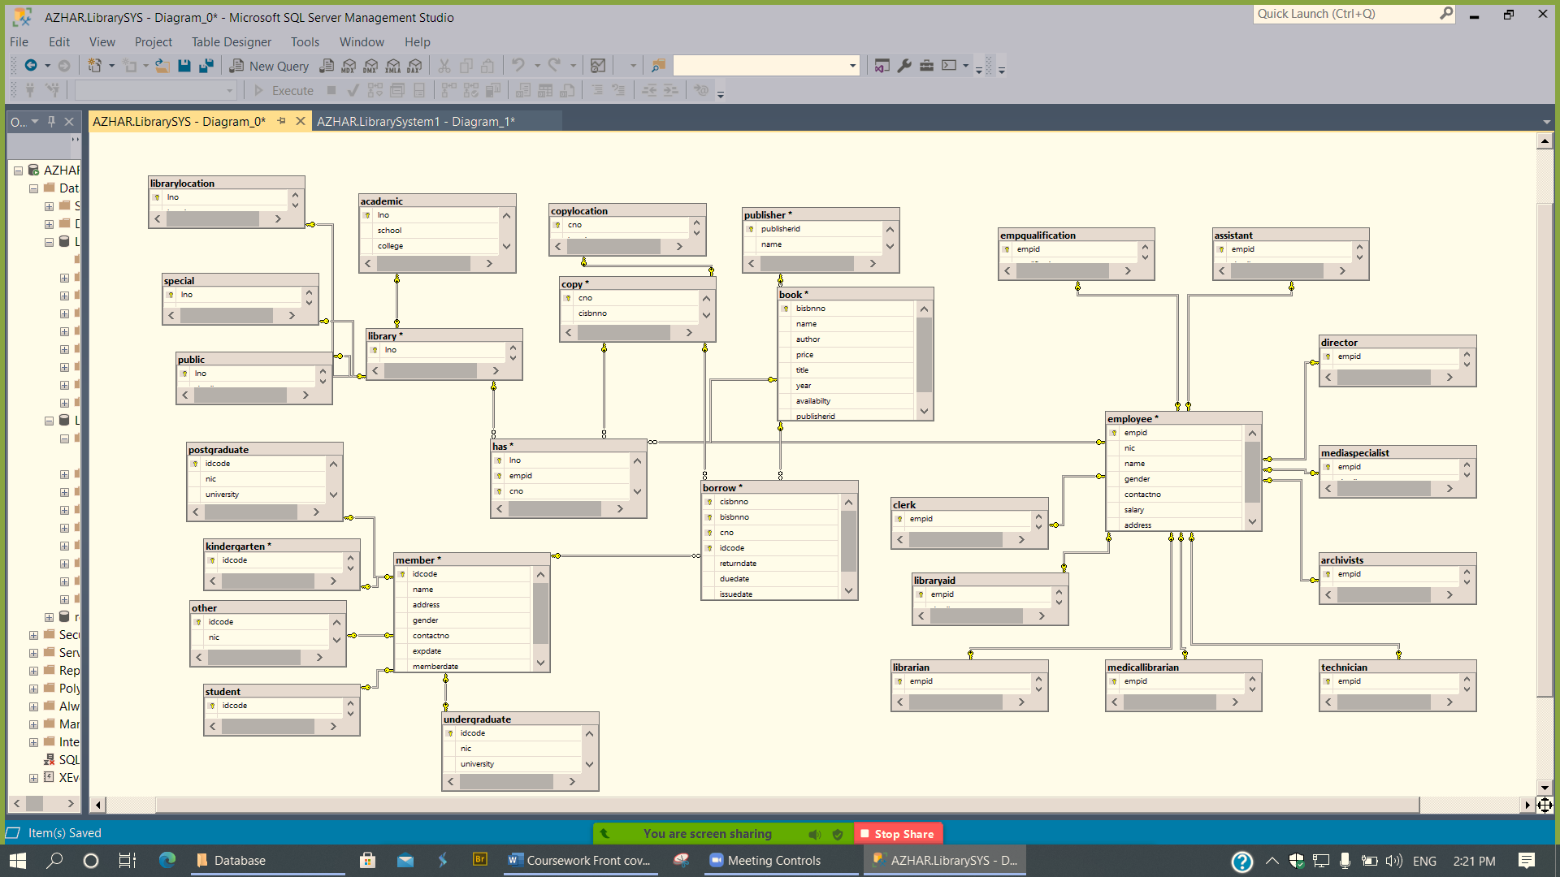

Figure 32: Database Diagram

# Section 03

## View

1. View

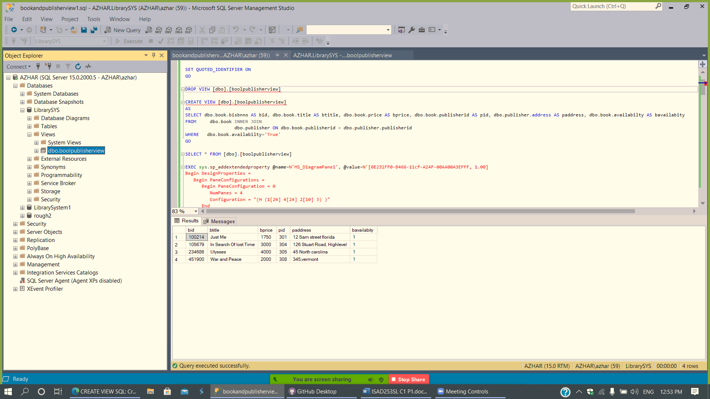

Figure 33: View

1. View

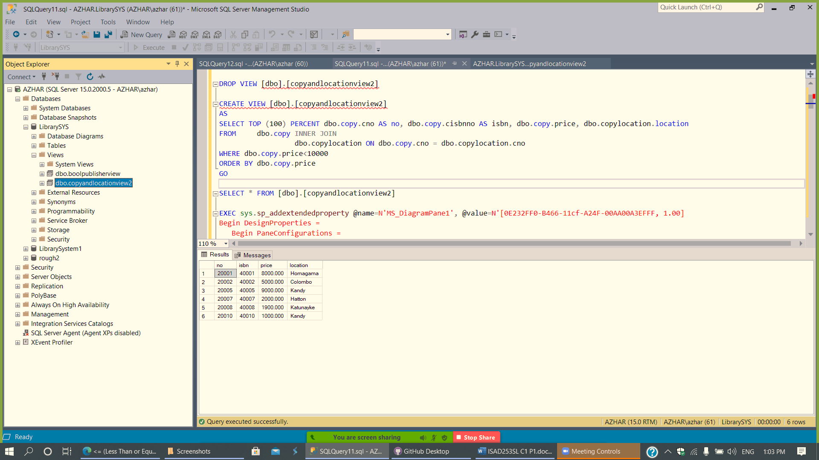

Figure 34: 2nd View

## Trigger

1. Trigger

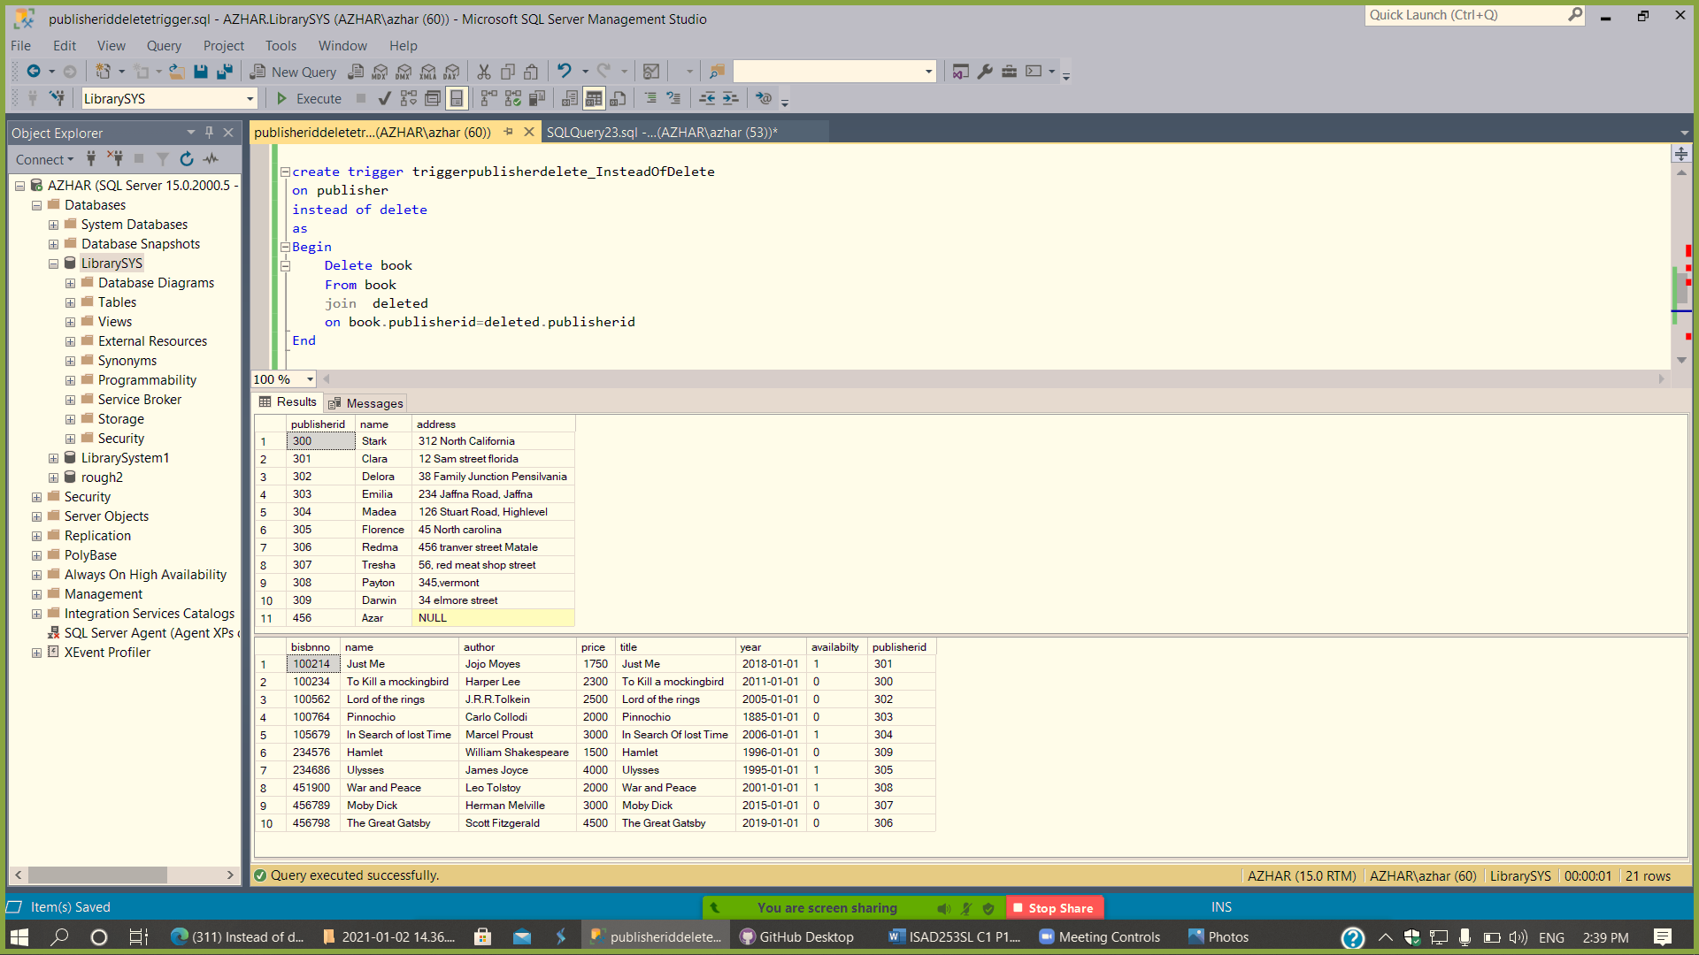

Figure 35: 1st Trigger

1. Trigger

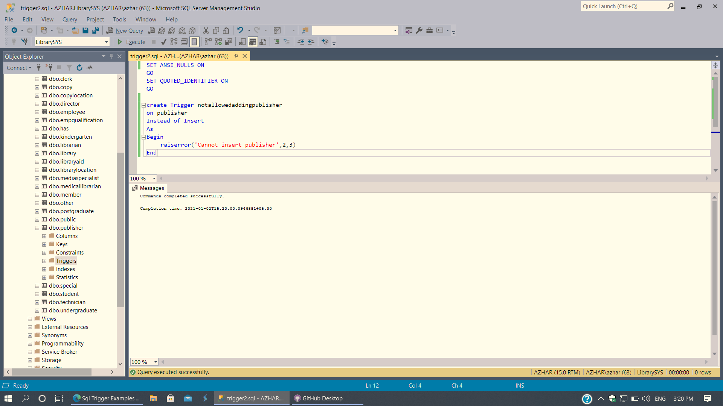

Figure 36: 2nd Trigger Create Code

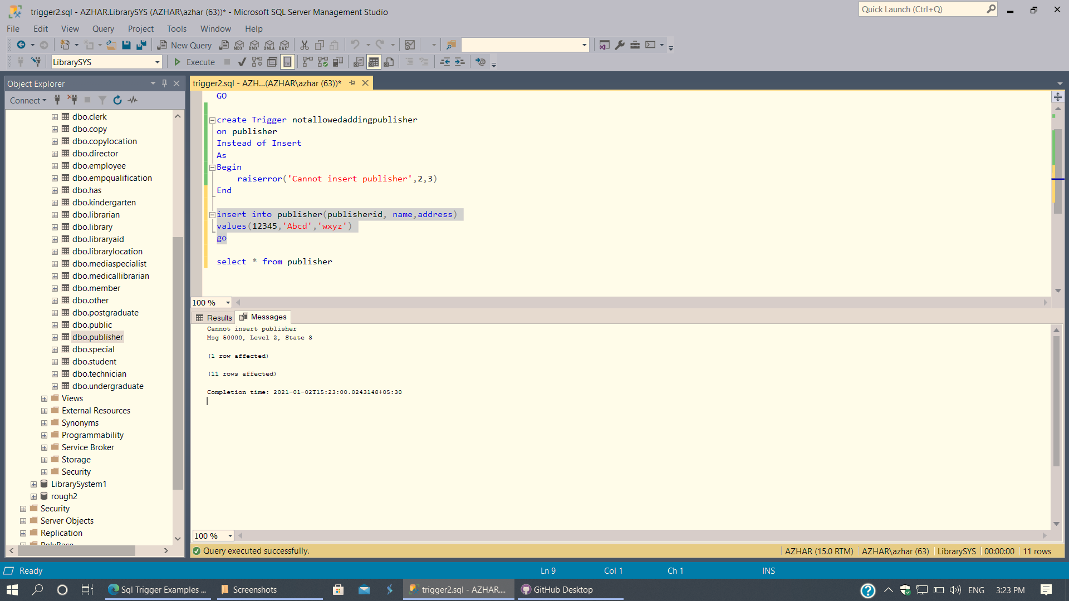

Figure 37: 2nd Trigger insertion

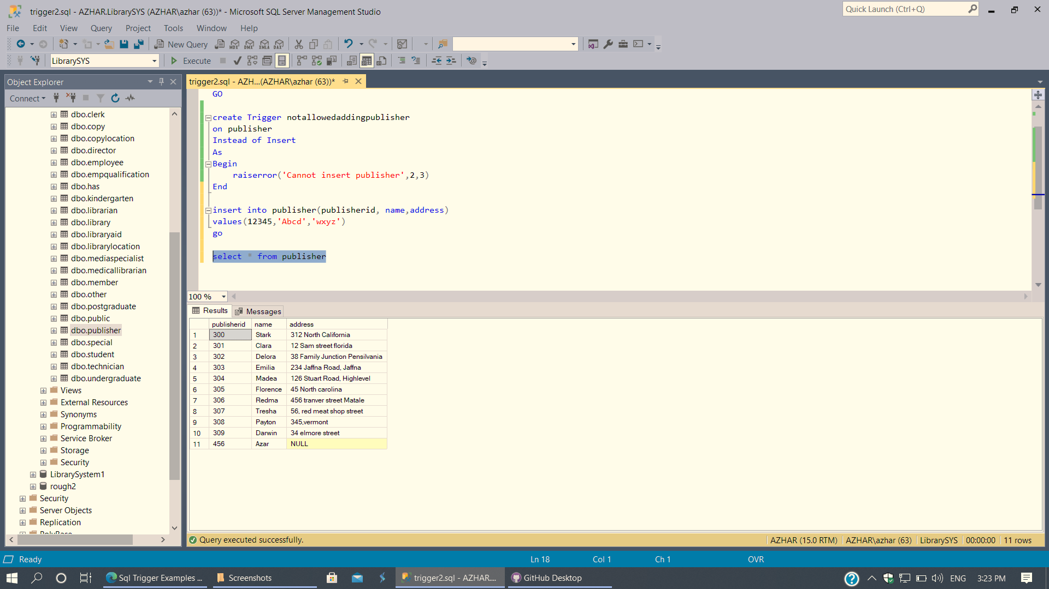

Figure 38: 2nd Trigger Execution

## Function

1. Function

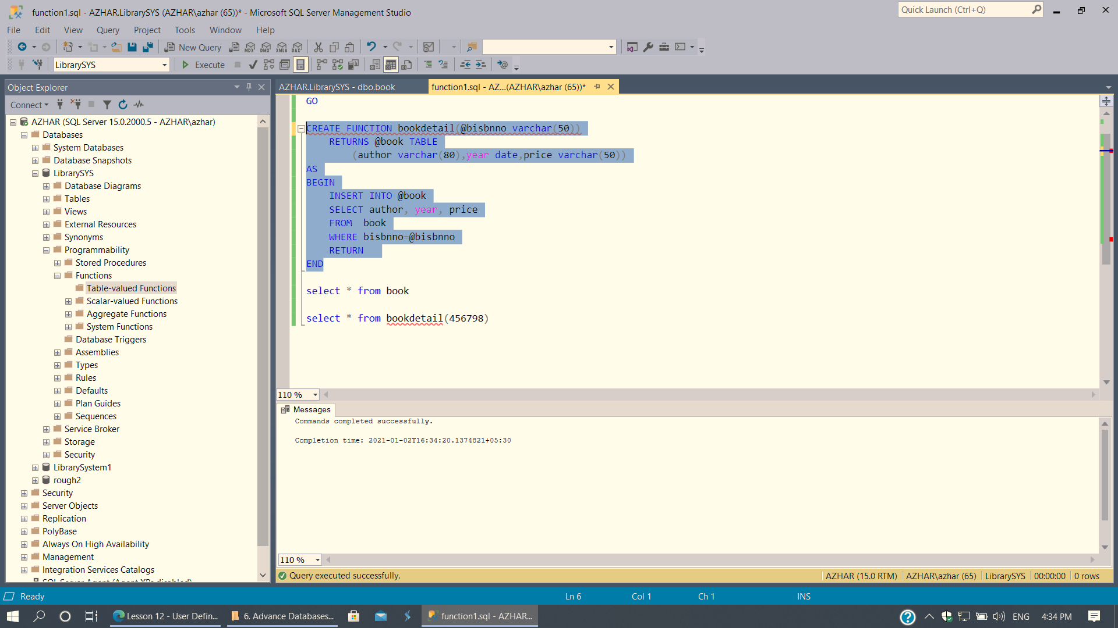

Figure 39: 1st Function Creation

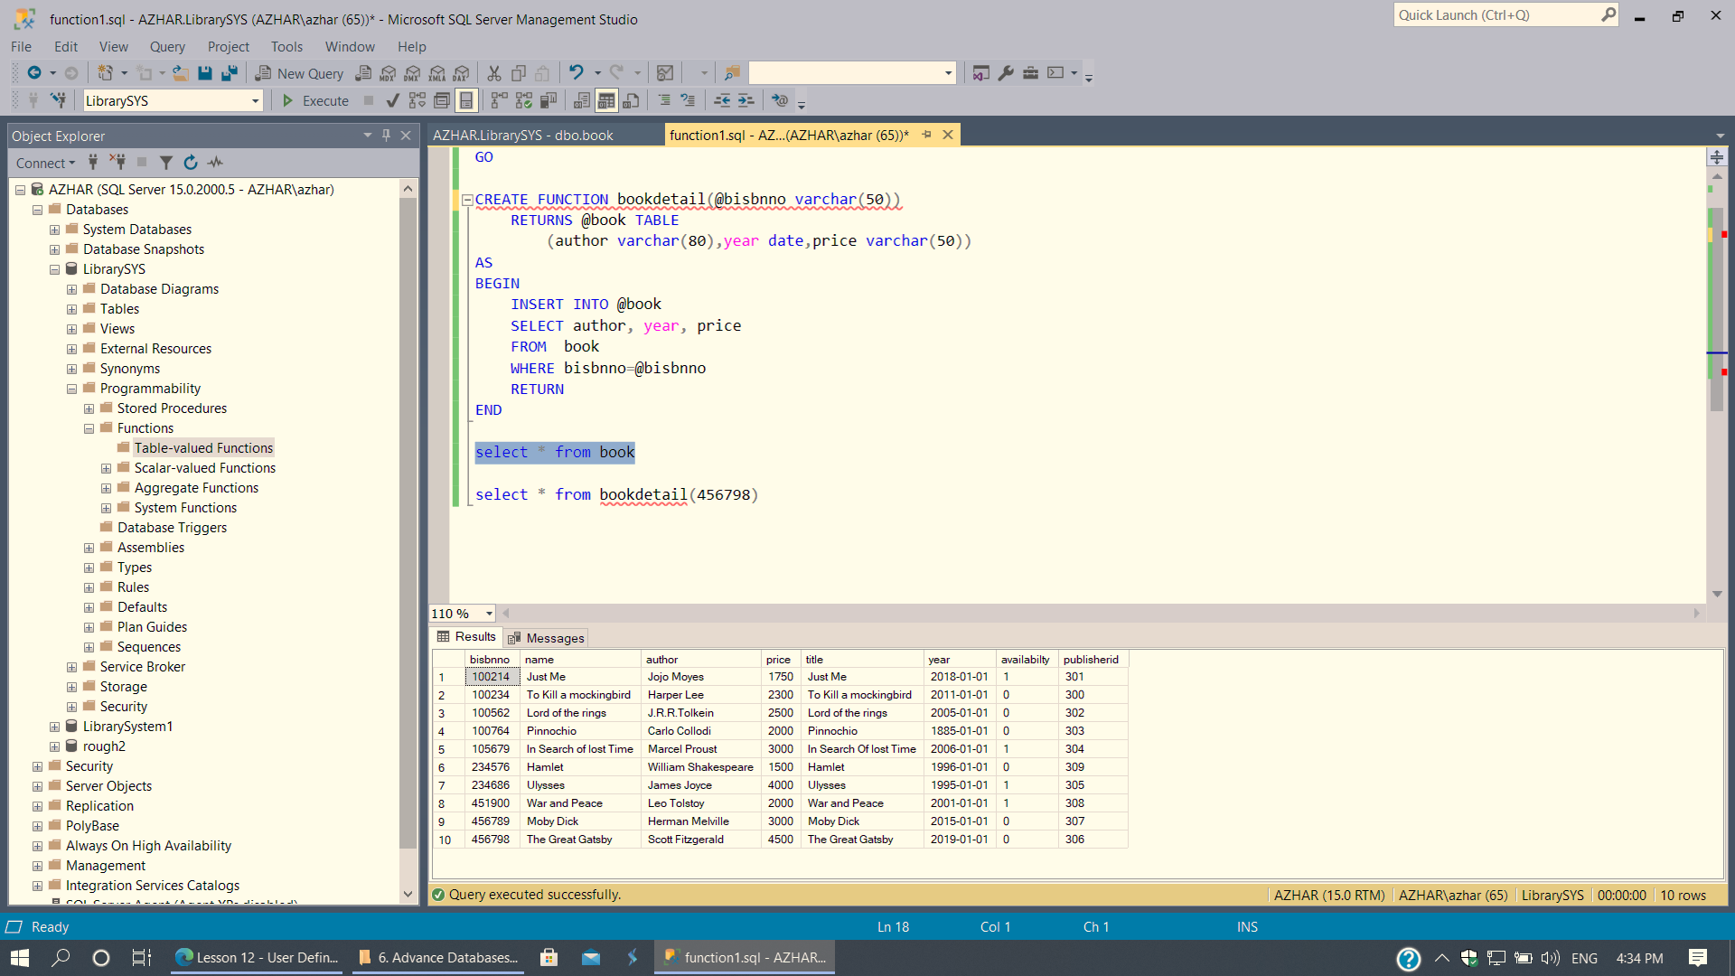

Figure 40: 1st Function Execution

1. Function

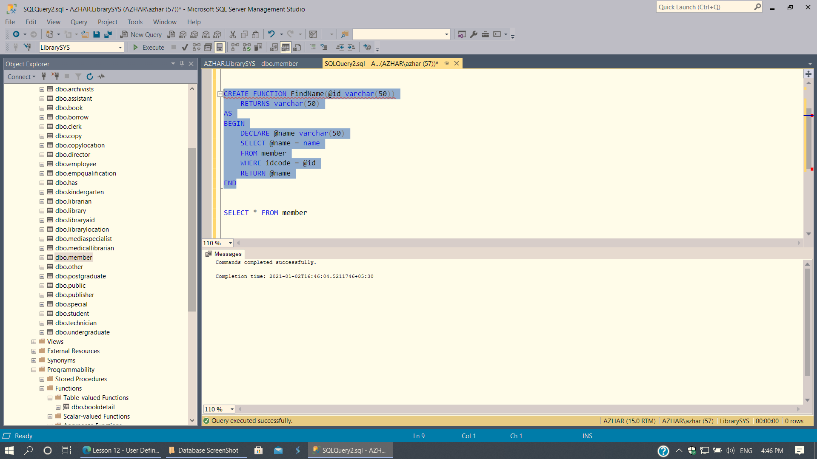

Figure 41: 2nd Function (Create Code)

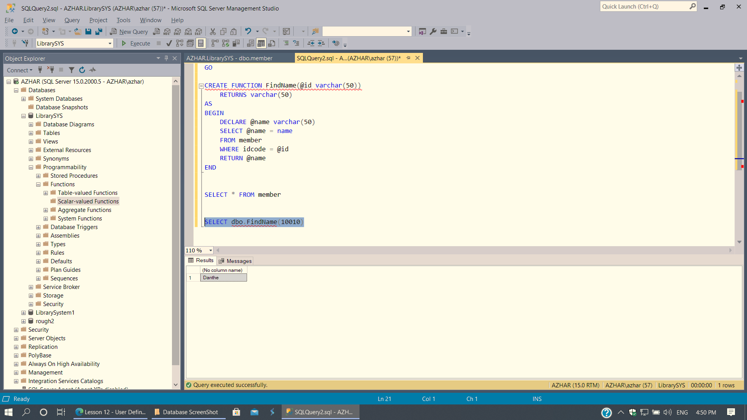

Figure 42: 2nd Function (Execution)

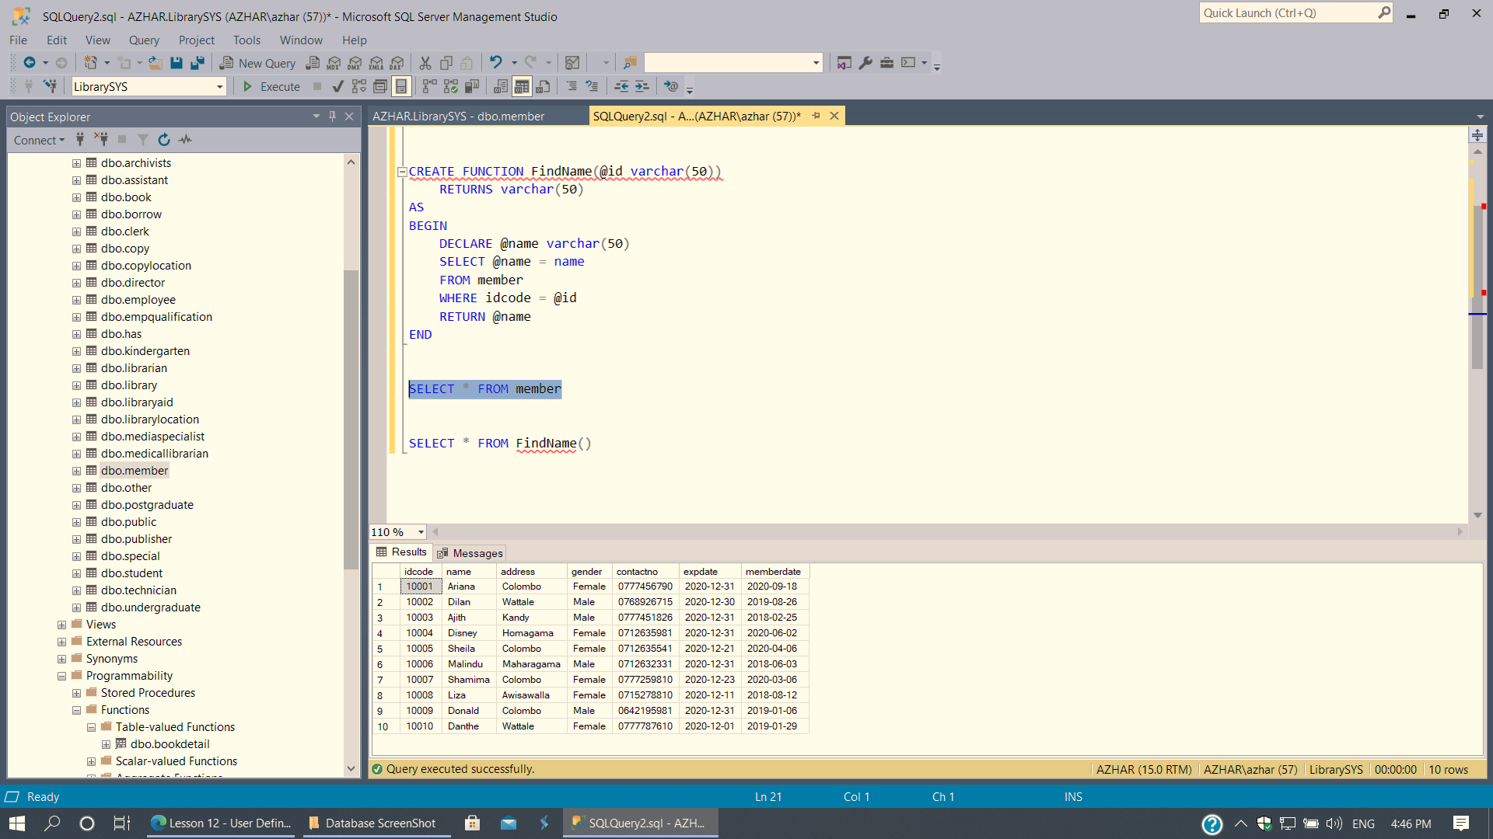

Figure 43: 2nd Function (selection code)

## Procedure

1. Procedure

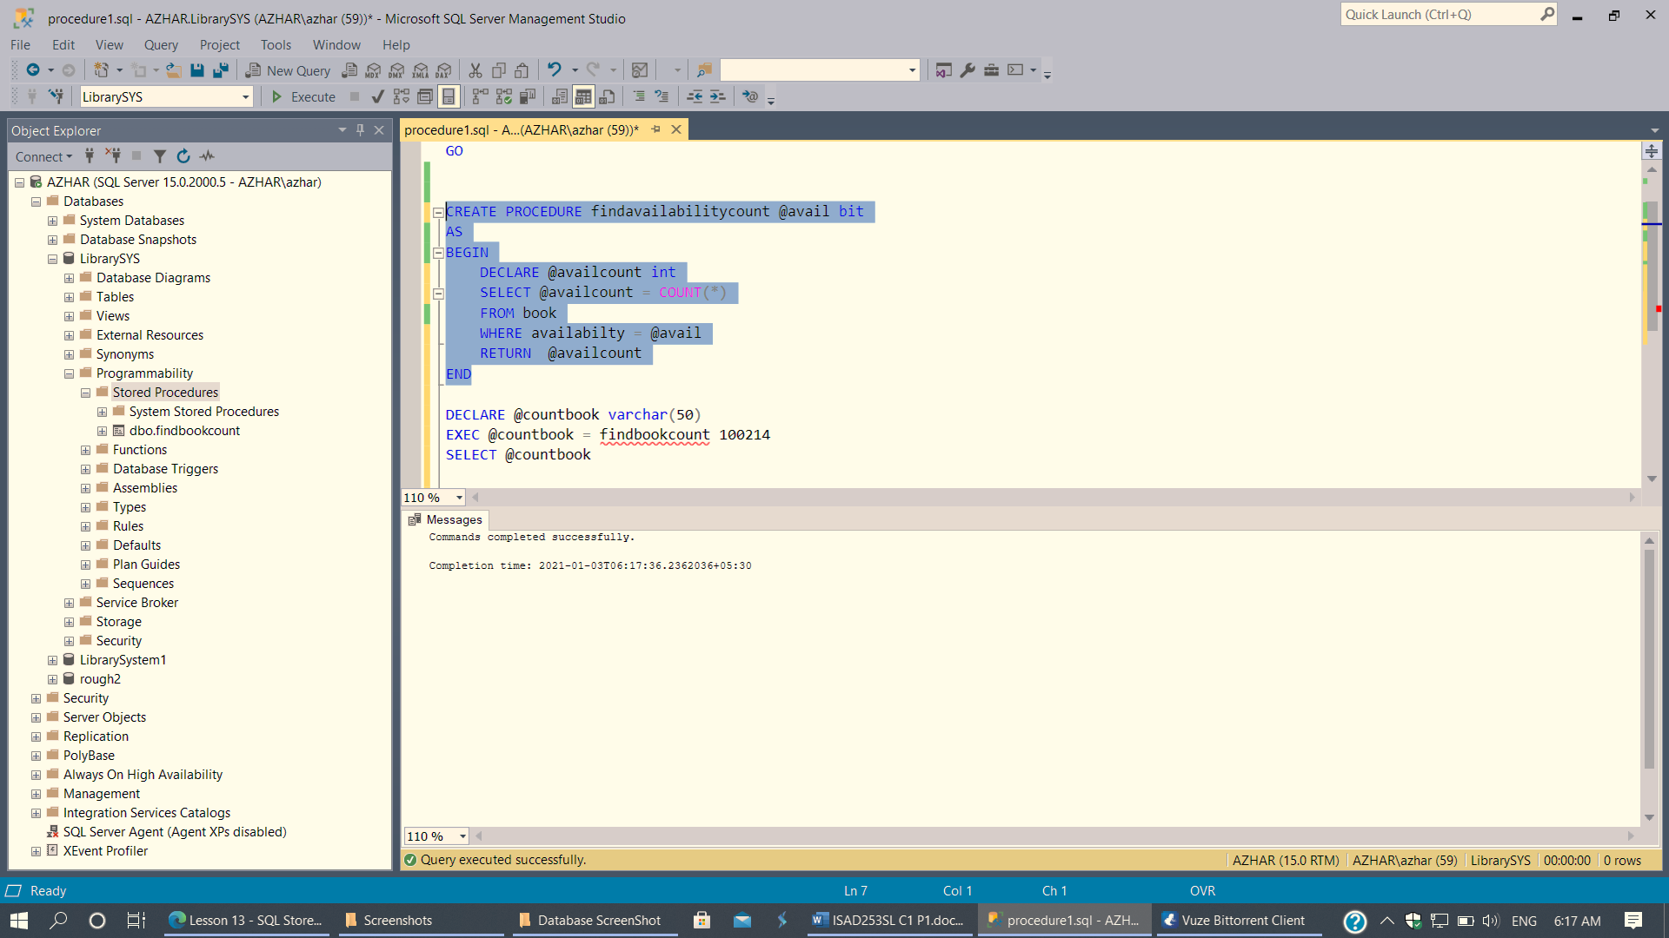

Figure 44: 1st Procedure (create)

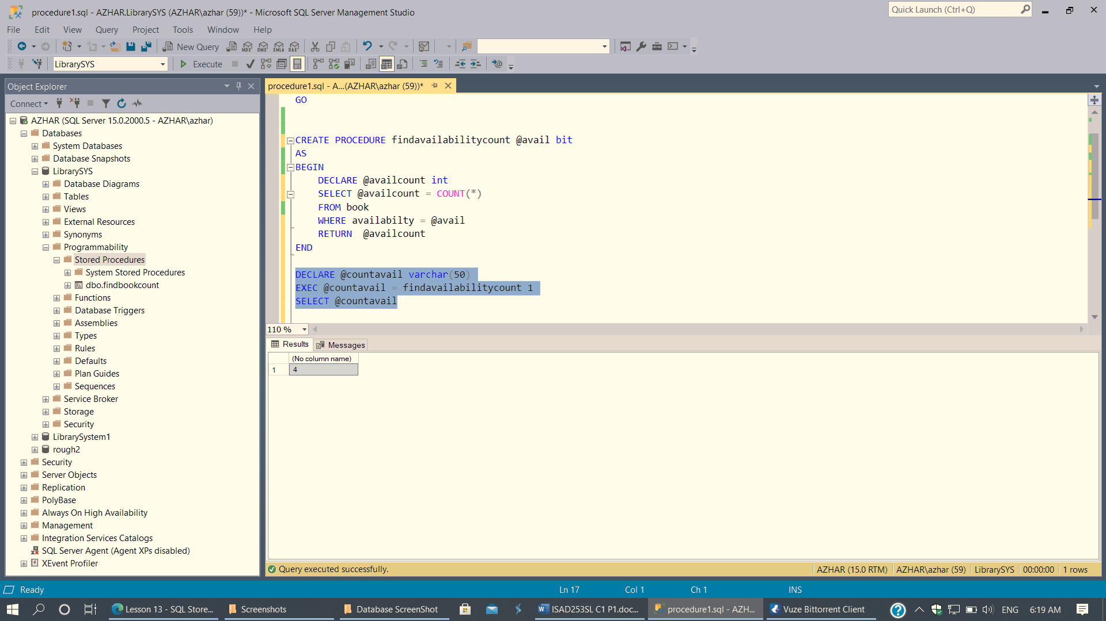

Figure 45: 1st Procedure (Execution)

1. Procedure

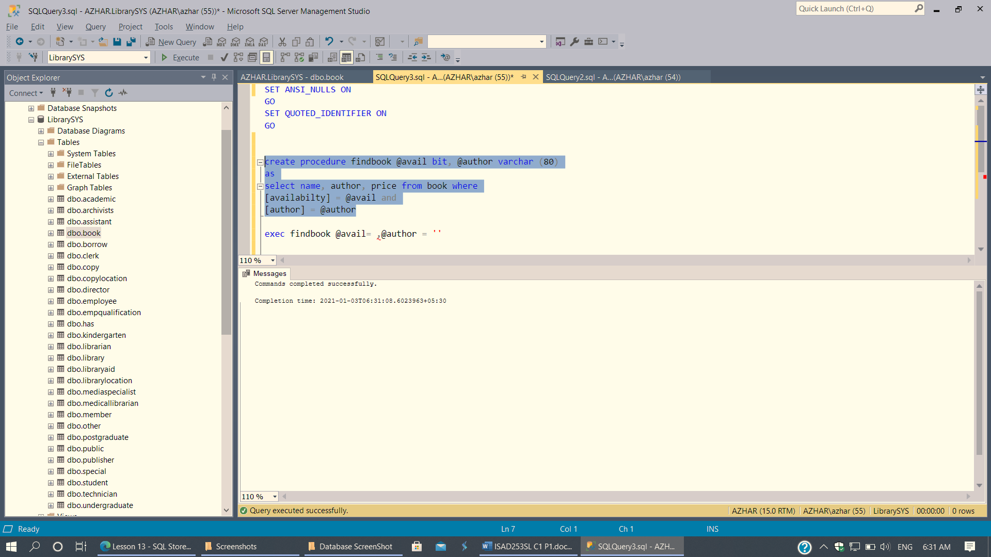

Figure 46: 1st Procedure (create)

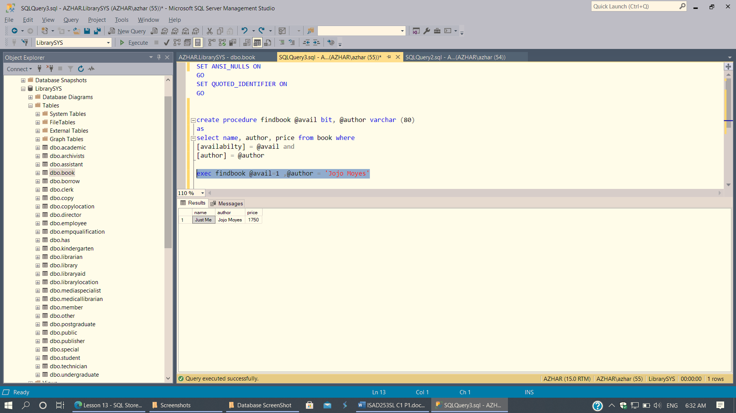

Figure 47: 2nd Procedure

# Section 04

## Worthy features

A worthy feature in our Library Service System is that we have broken down members into further categories like kindergarten kids, undergraduates, postgraduates, students, etc. this makes it easier for the member during application.

## Together with any shortcomings

There were many issues with how to do the tables and how to do them properly and there were some issues with the triggers.

## How they might be resolved

We watched and researched in many websites and YouTube, and then we made many mistakes but, in the end, we got it right

## Future Implementation

Sri Lankan public libraries still track books by hand, where they use a card system. This can be exhausting and slow. These libraries can benefit from this application if they implement it. They will save time, increase efficiency, and have less paperwork.

## Screenshots of everything remaining

1. Library

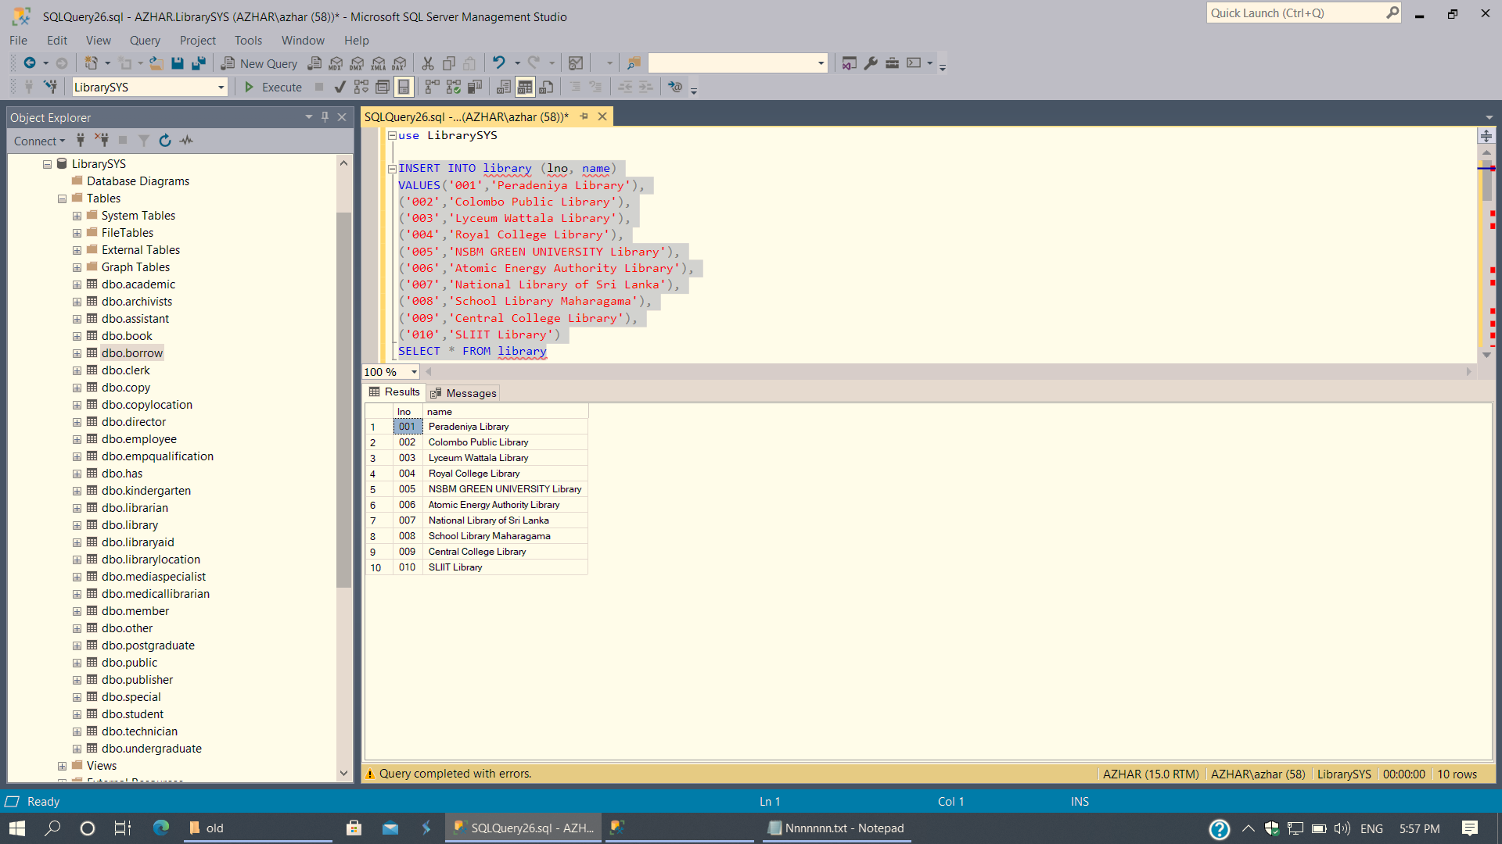

Figure 48: Library (Value Insertion)

1. Library Location

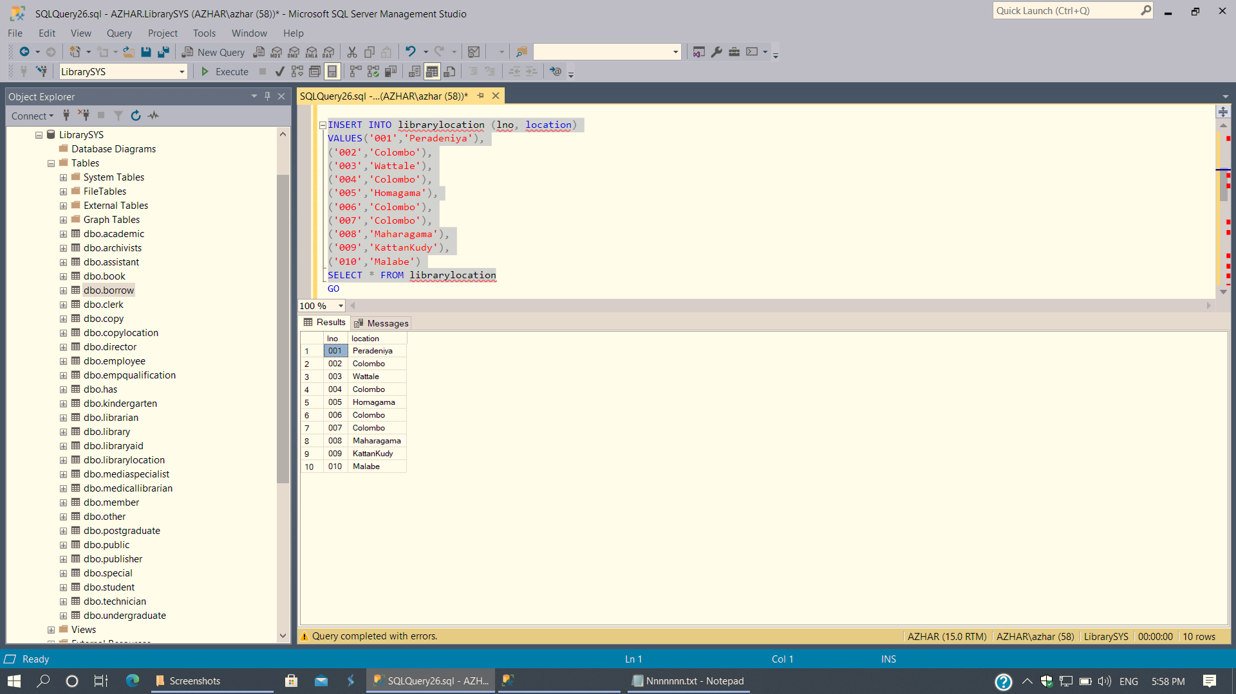

Figure 49: Library Location (Value Insertion)

1. Academic

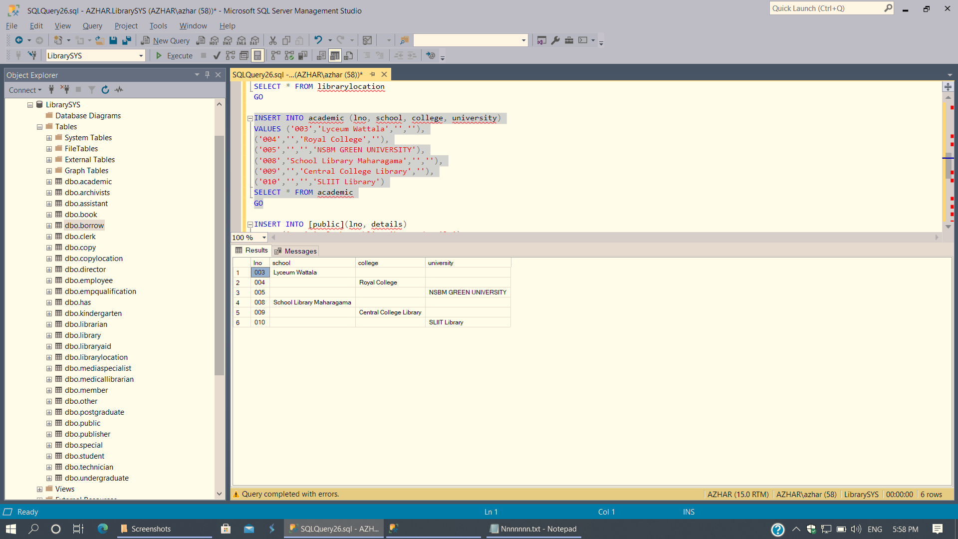

Figure 50: Library Academic (Value Insertion)

1. Public

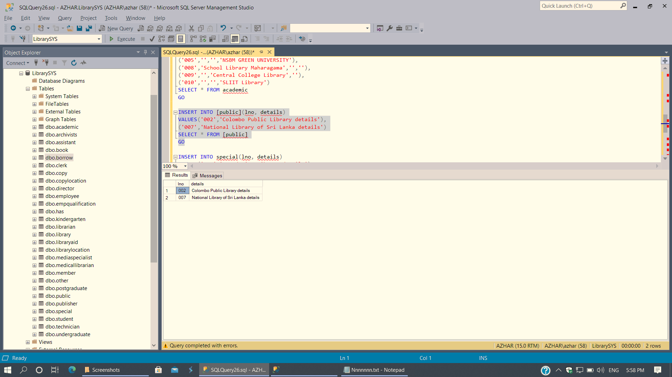

Figure 51: Library Public (Value Insertion)

1. Special

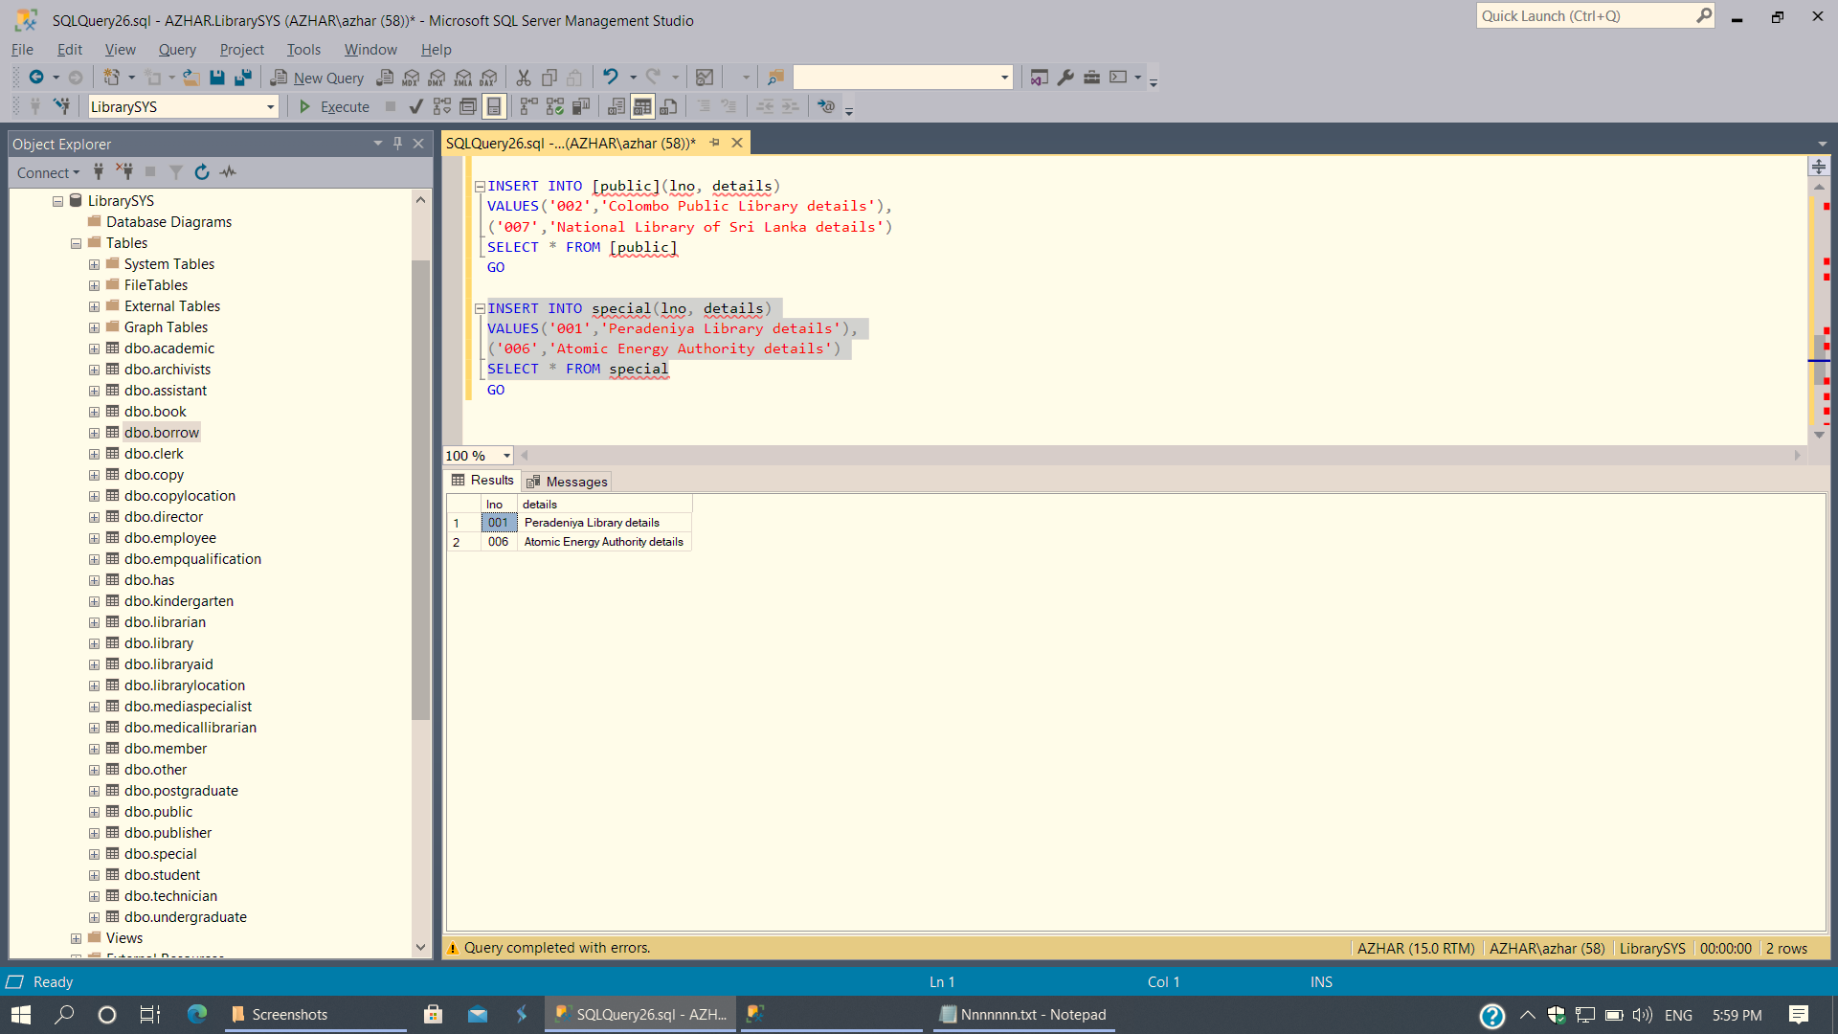

Figure 52: Library Special (Value Insertion)

1. Employee

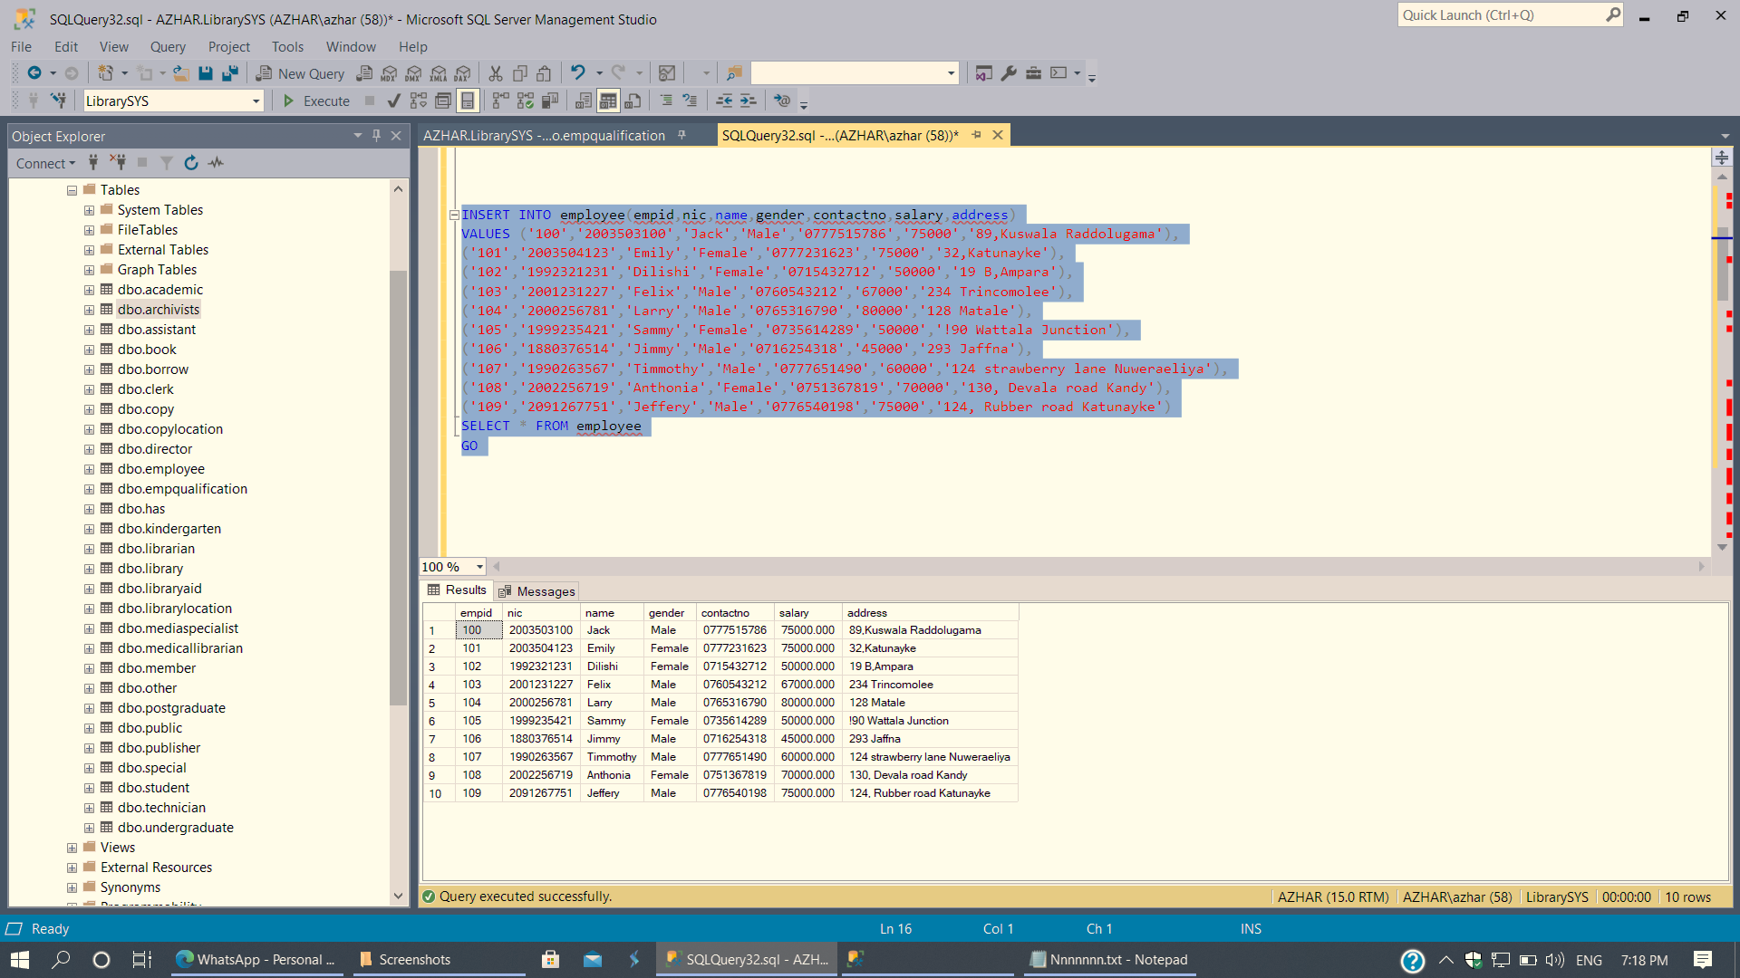

Figure 53: Employee (Value Insertion)

1. Employee Qualification

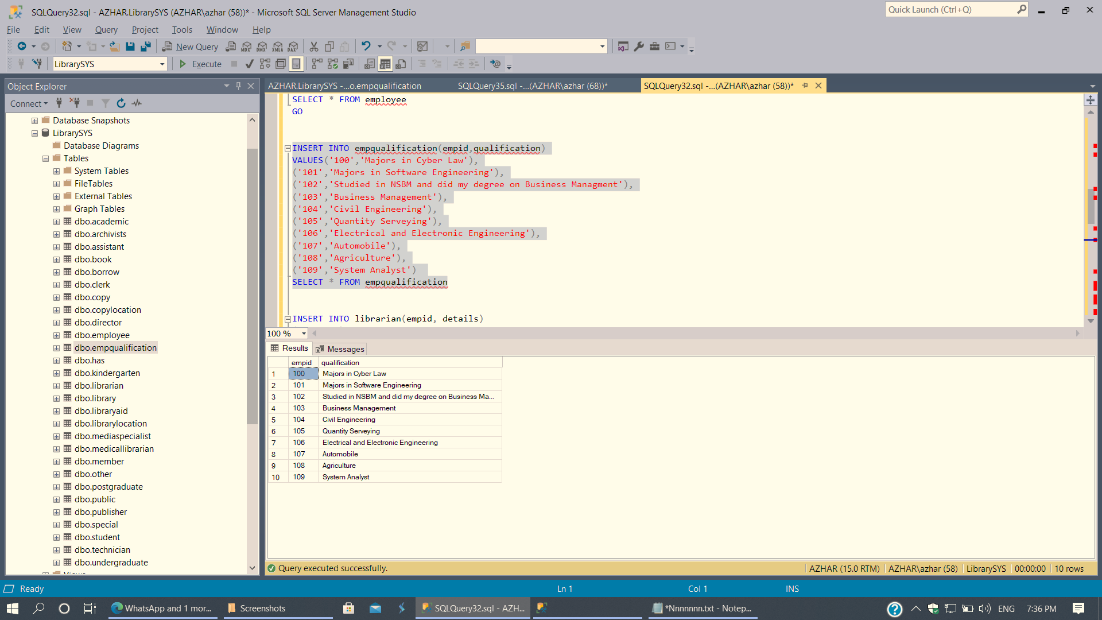

Figure 54: Employee Qualification (Value Insertion)

1. Librarian



Figure 55: Employee Librarian (Value Insertion)

1. Director

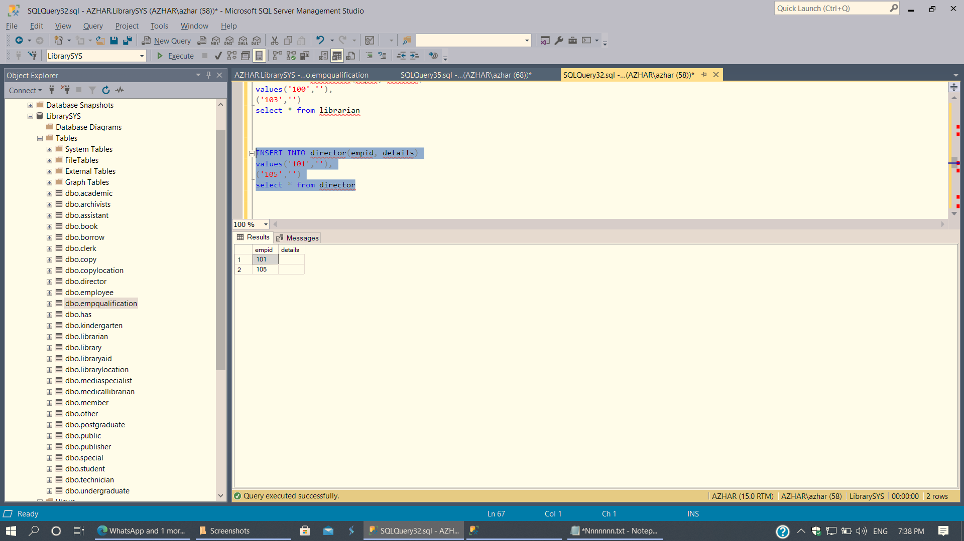

Figure 56: Employee Director (Value Insertion)

1. Medical Librarian

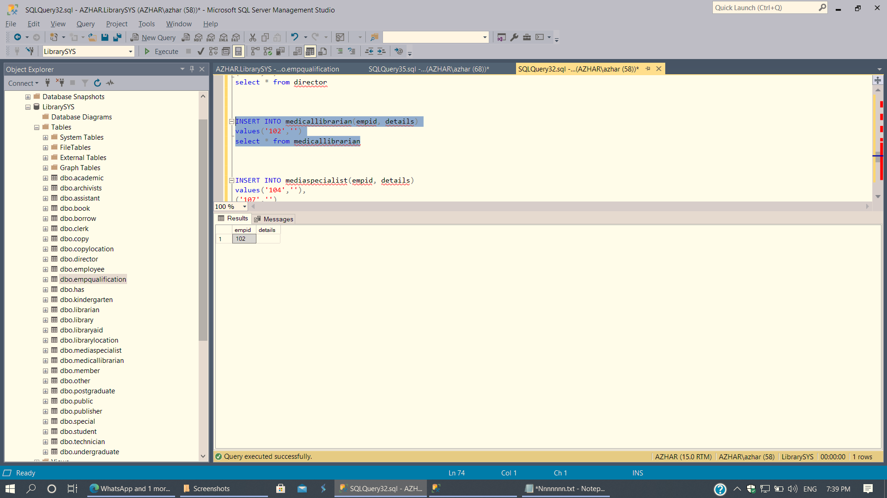

Figure 57: Employee Medical Librarian (Value Insertion)

1. Media Specialist

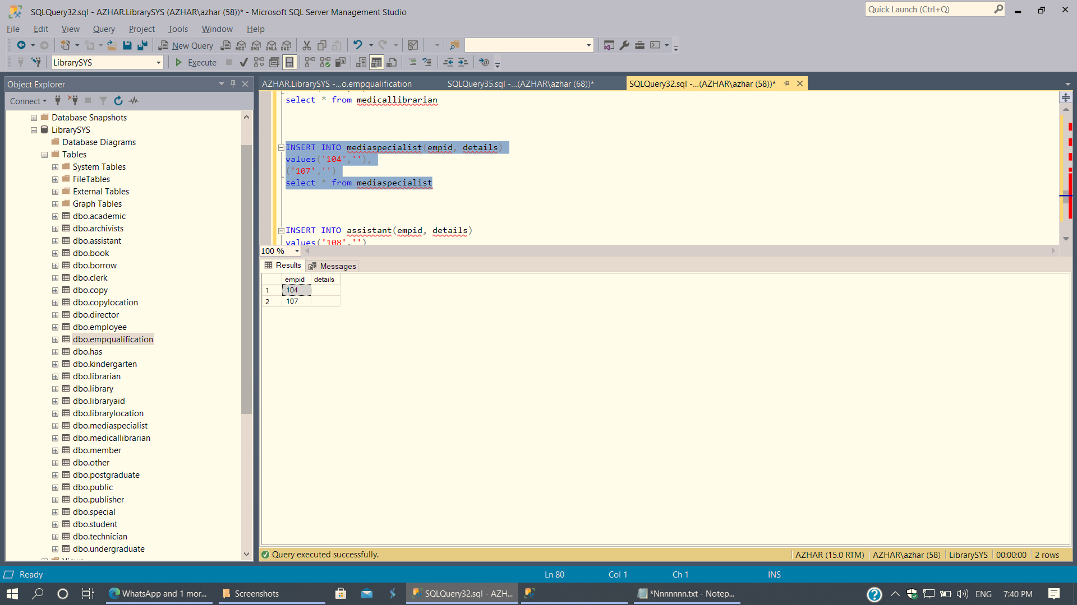

Figure 58: Employee Media Specialist (Value Insertion)

1. Assistant

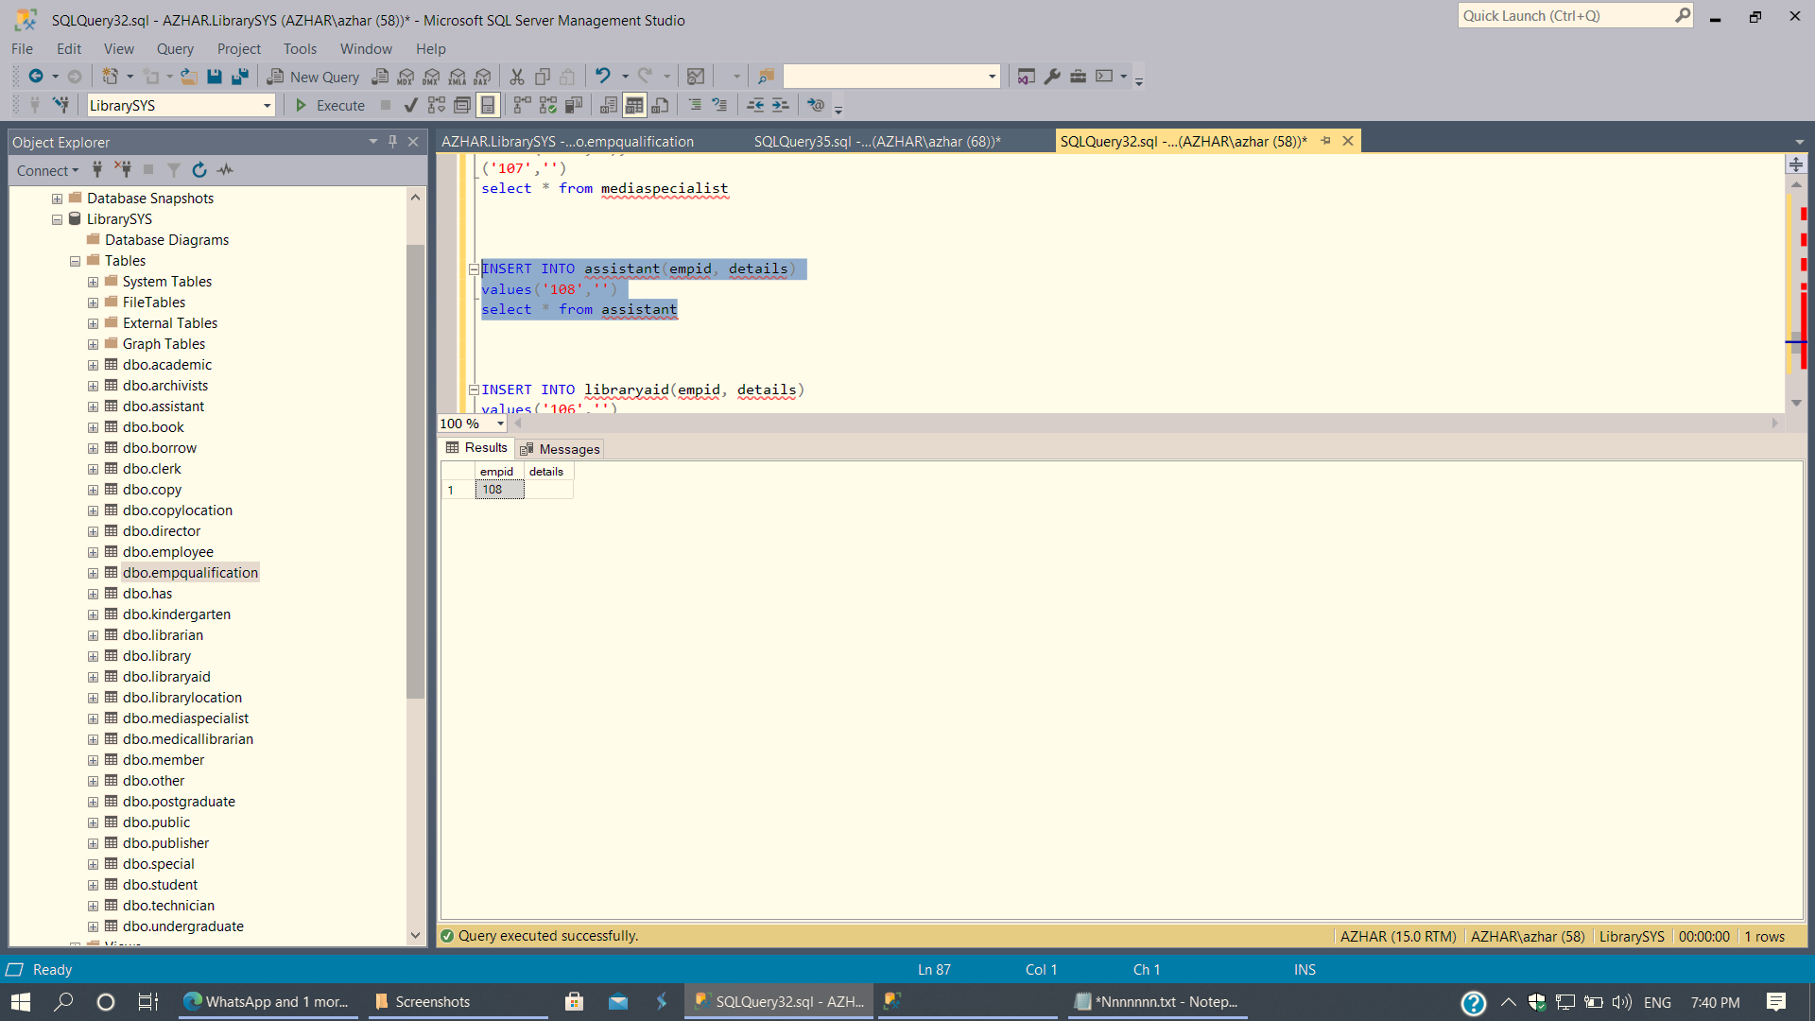

Figure 59: Employee Assistant (Value Insertion)

1. Library Aid

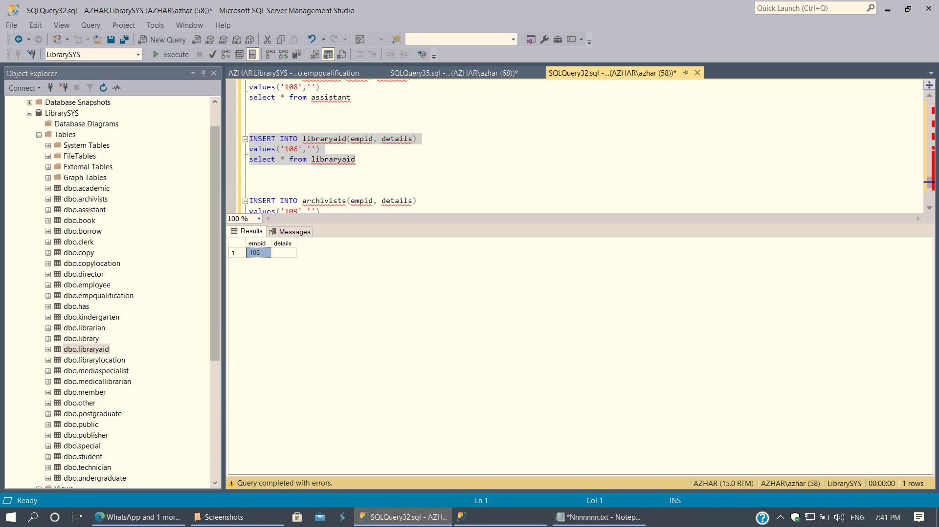

Figure 60: Employee Library Aid (Value Insertion)

1. Archivist

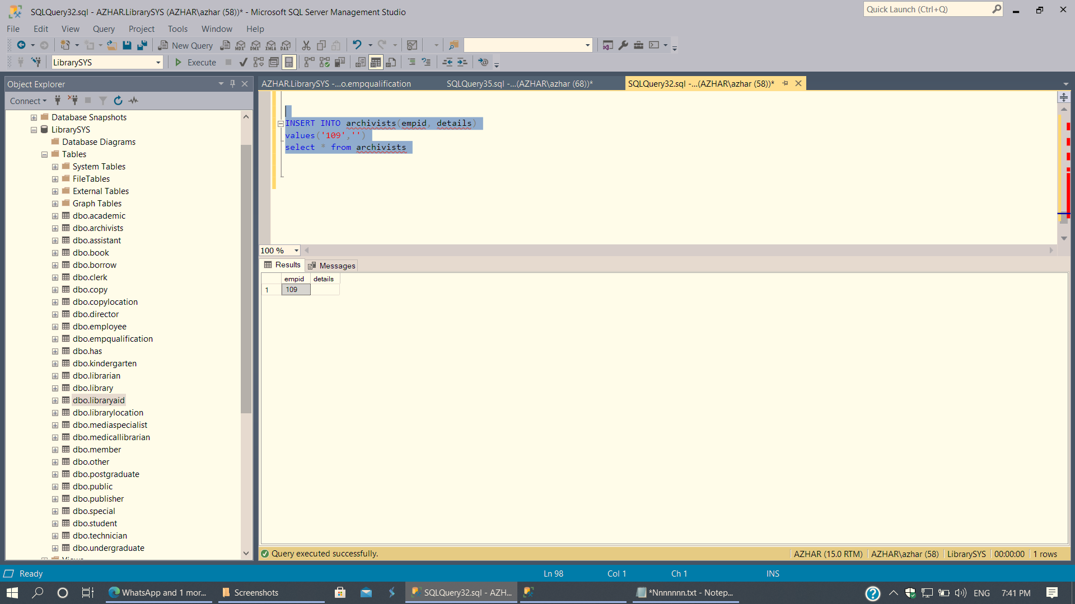

Figure 61: Employee Archivists (Value Insertion)

1. Publisher

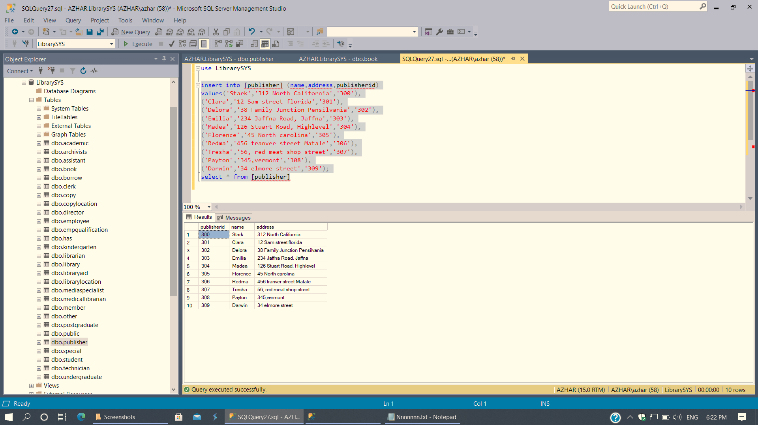

Figure 62: Publisher (Value Insertion)

1. Book

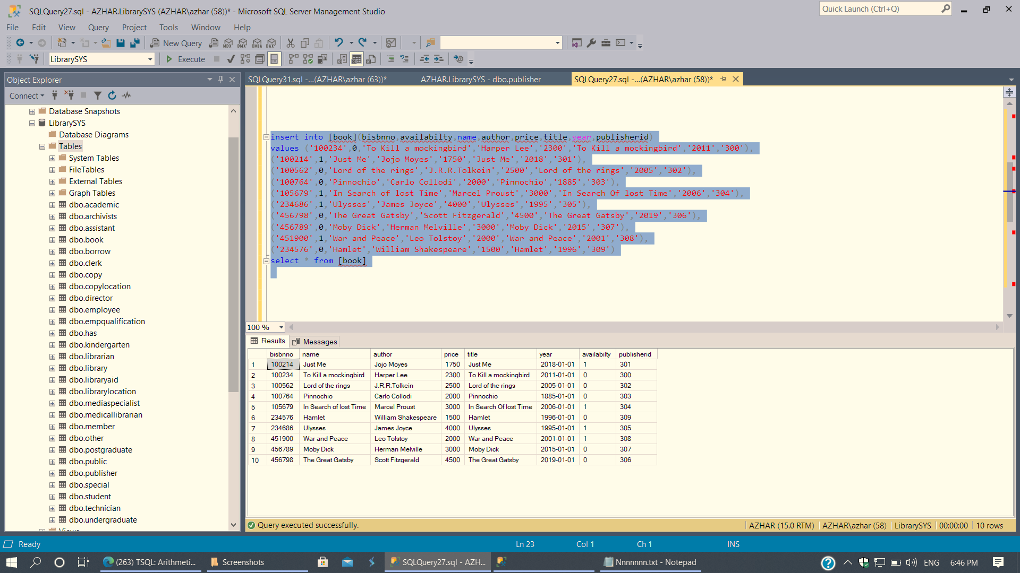

Figure 63: Book (Value Insertion)

1. Member

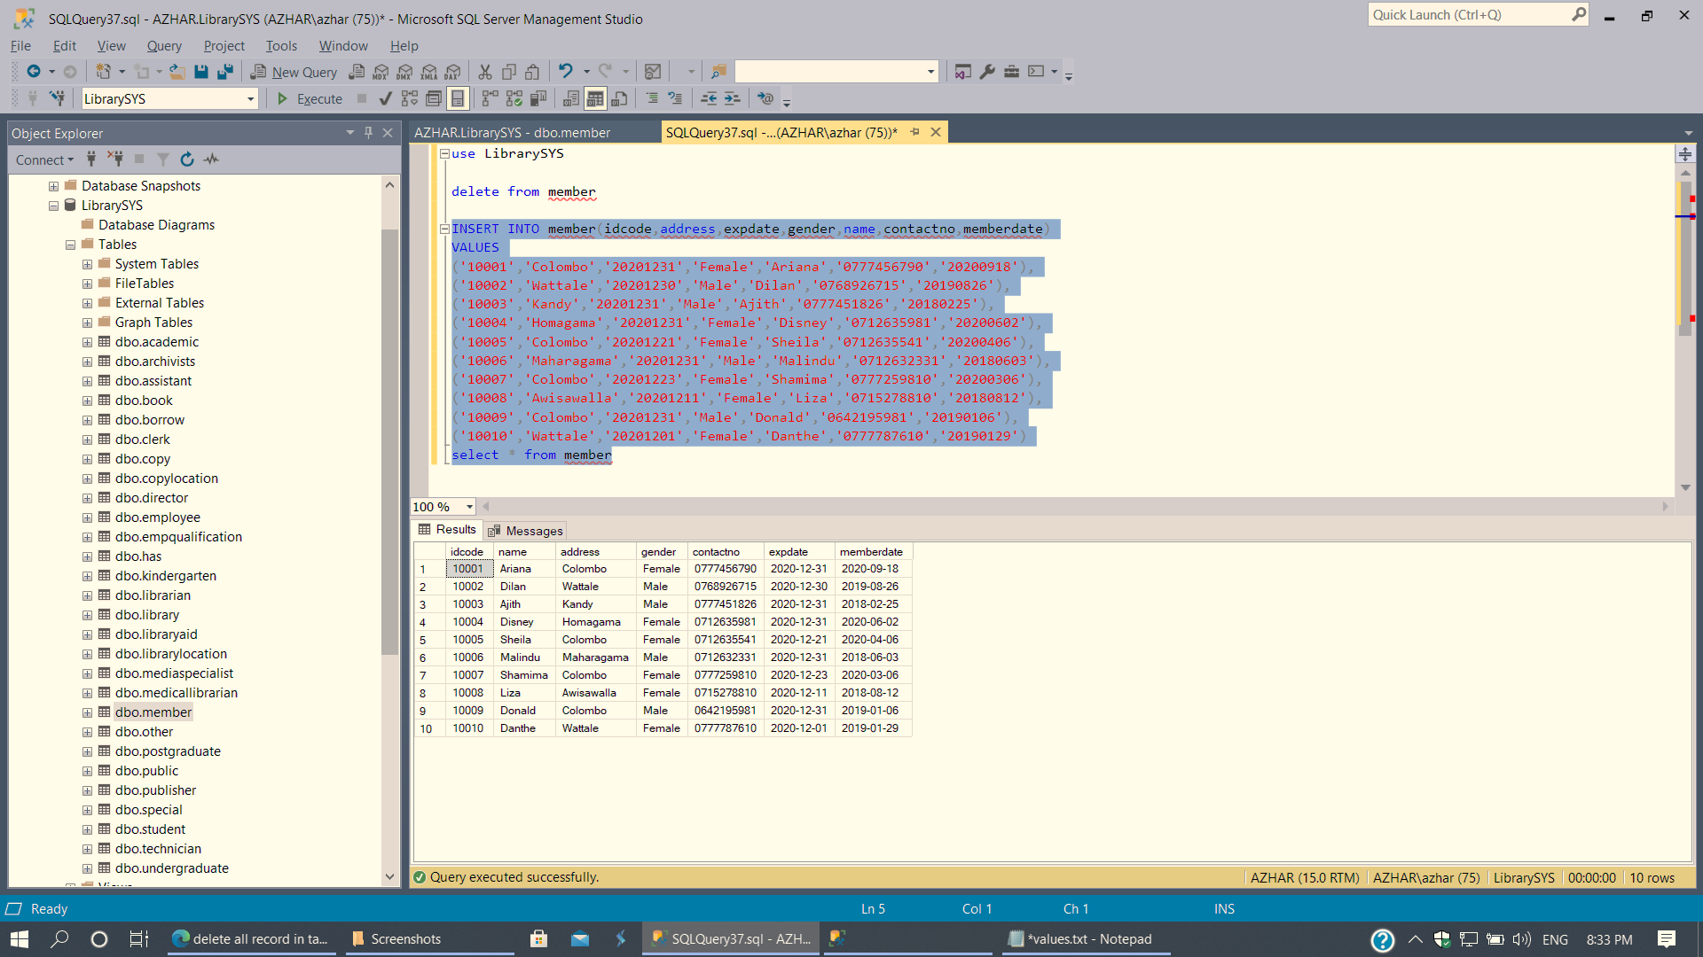

Figure 64: Member (Value Insertion)

1. Student

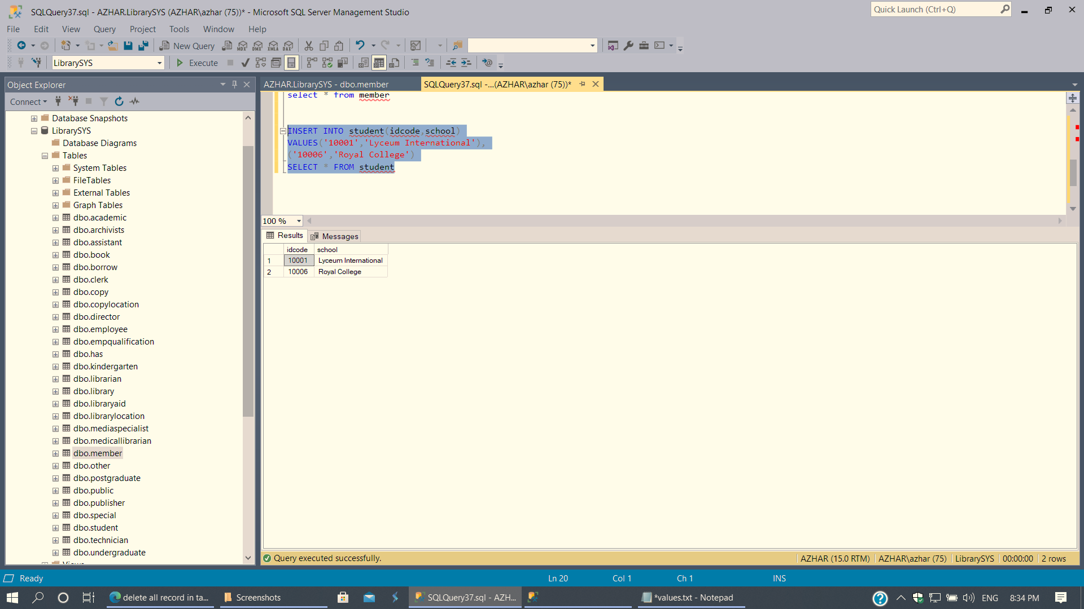

Figure 65: Member Student (Value Insertion)

1. Copy

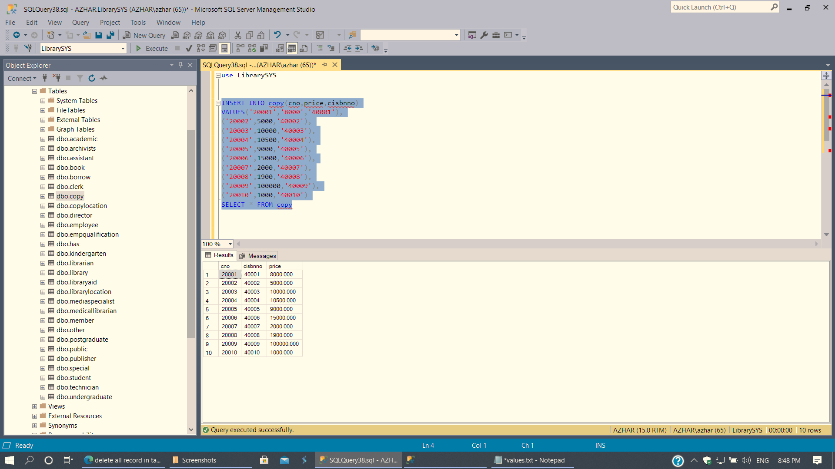

Figure 66: Copy (Value Insertion)

1. Copy Location

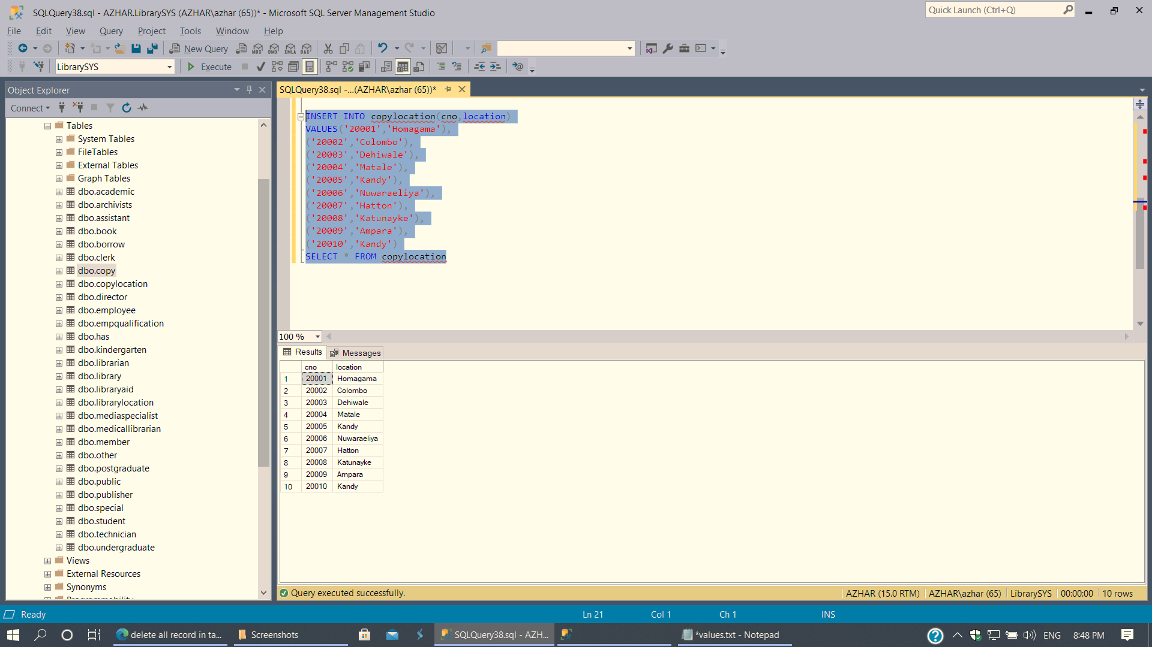

Figure 67: Copy Location (Value Insertion)

1. Has Relationship

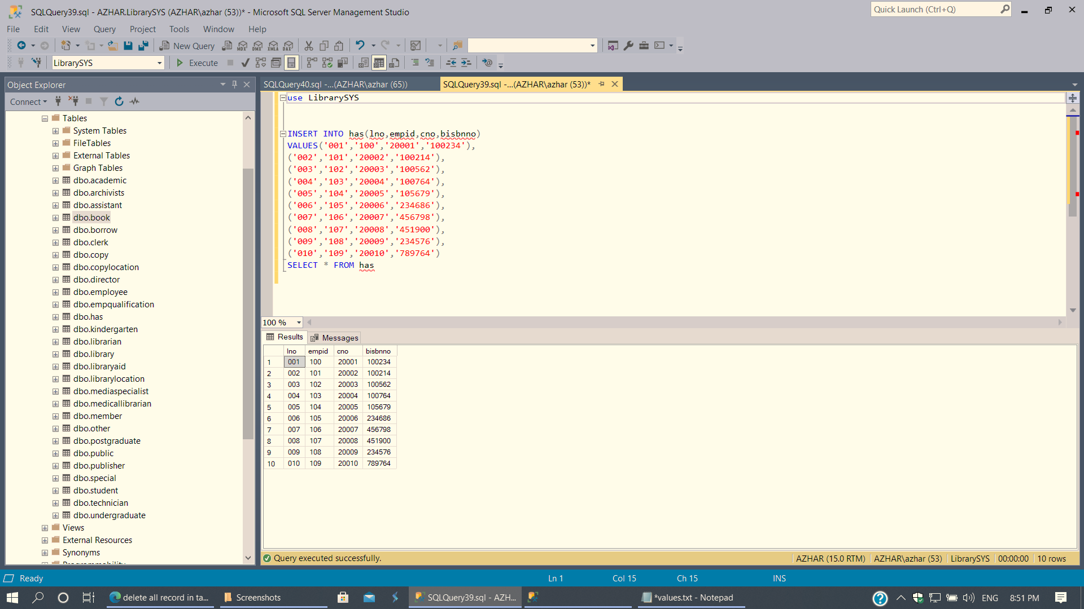

Figure 68: Has Relationship (Value Insertion)

1. Borrow Relationship

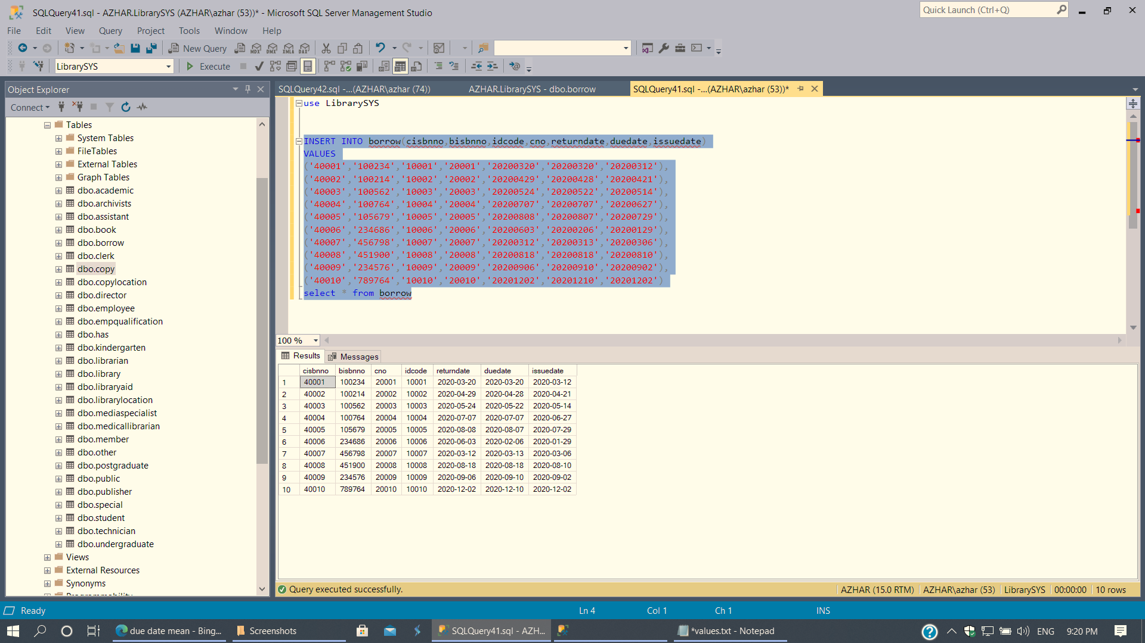

Figure 69: Borrow Relationship (Value Insertion)

# Workload Matrix

|  |  |  |  |  |  |  |
| --- | --- | --- | --- | --- | --- | --- |
| Member Activity | J A Mujeeb | S S N S Nevins | G M D D Ratnayke | S O Perera | S P Ratnayake | W N D Perera |
| Section 01 | S | S | S | S | S | R |
| Section 02 | R | S | R | S | S | S |
| Section 03 | R | R | S | R | S | S |
| Section 04 | R | R | R | R | S | S |
| Report | R | R | R | R | S | R |
| Presentation | S | R | R | R | S | S |

R - Responsible Member

S - Supporting Member